Guide to the Form 1 (new application) PI Response form
Disclaimer: These instructions pertain to the Form 1 PI Response form; however, the other PI Response forms are very similar, so this guide will be helpful for all PI Response forms (Form 2: Change Request/Amendment, Form 3: Continuing Review Submission, etc.).
When the IRB sends you recommendations or provisos (i.e., instructions or questions regarding your project), you will receive a PI Response form under your “All Tasks” tab on your home page of iMedRIS. The PI Response form should be labeled “Submission Response”. When you log in to iMedRIS, you should see this:
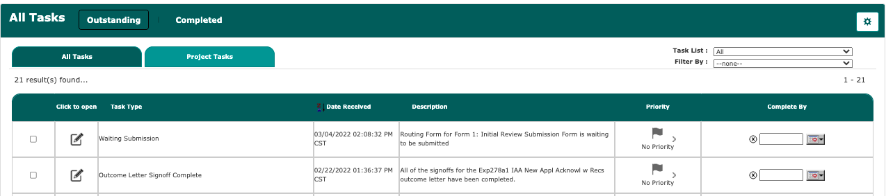
Clicking the “Project Tasks” tab will provide more information about the Submission Response including the project status, project title, principal investigator and IRB number.
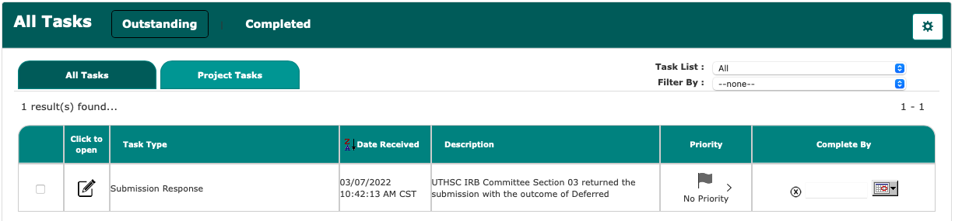
Click the “Open” icon from either the “All Projects” or “All Tasks” tab to open the response form.
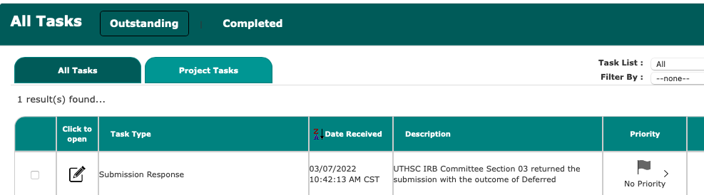 OR 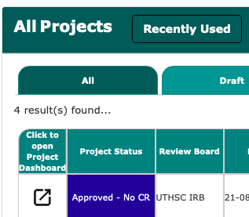
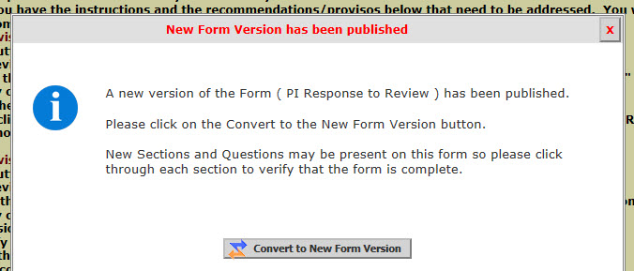
Click the “Convert to New Form Version” button to close the pop-up window and convert (i.e., update your form).
If you do not get a pop-up window that has the “Convert to the New Form Version” button, then you have the most up-to-date version of the PI Response form, and you should proceed with these instructions.
Scroll down past the yellow instructions to where your recommendations or provisos from the IRB are listed under the section header “Issues Requiring a Response” (see the red arrow below).
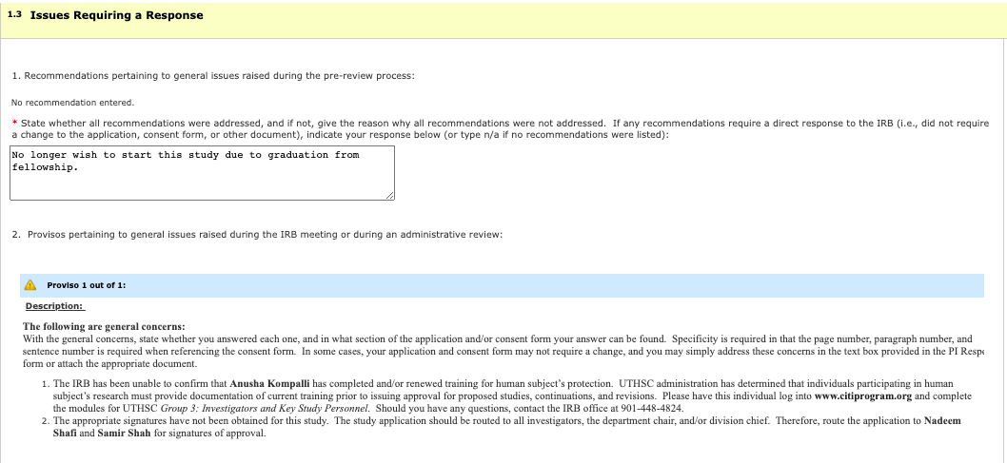
Print these provisos or open a different internet browser window so that you can view them while you are working within the response form. Note: You cannot open 2 windows of the same browser. You must use, for example, Safari and Google Chrome.
In addition, you may have received a letter through iMedRIS correspondence that includes the same provisos, and you can also print the letter and use it to view your provisos while you are working within the PI Response form.
Lastly, if you attempt to save the PI Response form before you answer all of the questions, you will get an alert in red text instructing you to answer the questions you missed.
Next, scroll down to section (250) entitled Revise and Attach Documents.

---------------------------------------------------------------------------------------------------------------------
If you have recommendations/provisos to REVISE the APPLICATION, click the icon next to the application in the column entitled “Revise/Attach”.
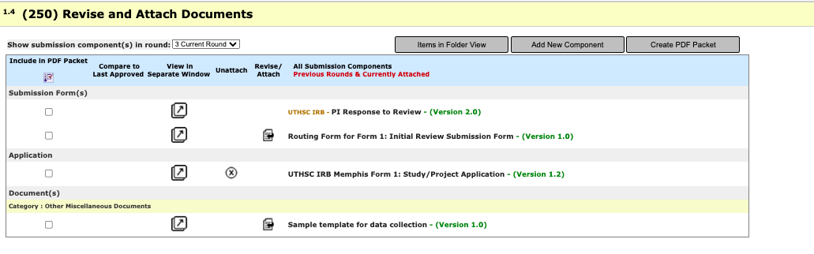
There will be a pop-up window confirming the revision. You should click “CONFIRM.”
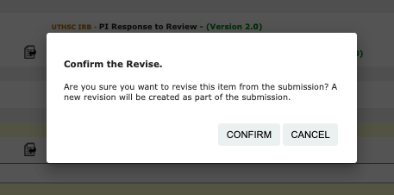
An “editable” version of your application will appear, and you should click the section on the left that you need to edit (see the green arrow below). Once you complete a revision of one section of the application, don’t forget to click the “Save and Continue to Next Section” button at the top right-hand side of the screen (see the red arrow below).

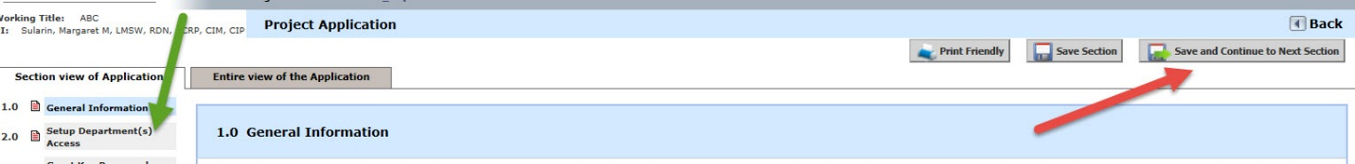

Note: You can only access the “Save and Continue to Next Section” button in order to make changes if you are in the “Section view of Application” (as opposed to the “Entire view”) – in the picture above, the green arrow is pointing to the Section View tab on the far left-hand side of the screen.
Also Note: Any changes that you make that were not requested by the IRB must be delineated in question #3 of the PI Response form. Make notes of these changes as you go through the application so that you can list them when you get back to the PI Response form.
Click “Save and Continue to Next Section” through each sections making the necessary changes. When you click “Save and Continue to Next Section” on the last section/page of the application, it will also take you back to the PI Response Form. This will take you back to the PI Response Form and you will see the new version of your application there (see the red arrow below).
Note: Once you have clicked the icon to revise any submission components, the “Revise/Attach” column next to those components will be empty. If you need to go back in at a later time and make further edits, simply click on the application title, “UTHSC IRB Memphis Form 1: Study/Project Application,” to open and revise it. This will take you directly into the application that you have just revised (green arrow below).

Back in the PI Response Form, you can access other documents to edit, such as the consent form. ---------------------------------------------------------------------------------------------------------------------
If you have recommendations/provisos to REVISE a CONSENT FORM that you initially submitted to the IRB, click the icon next to the consent form in the column entitled “Revise/Attach”.
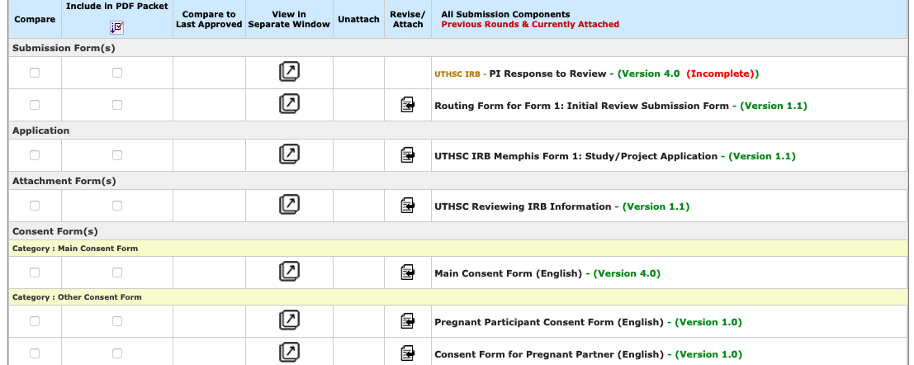
There will be a pop-up window confirming the revision. You should click “CONFIRM.”
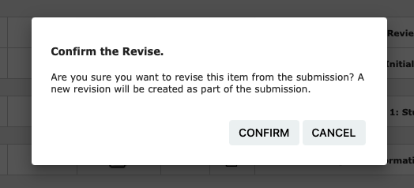
Another pop-up window will inform you that a new version has been created.
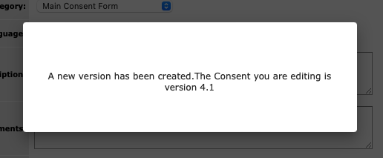

In the next window, click on the “Check-out Document” button.
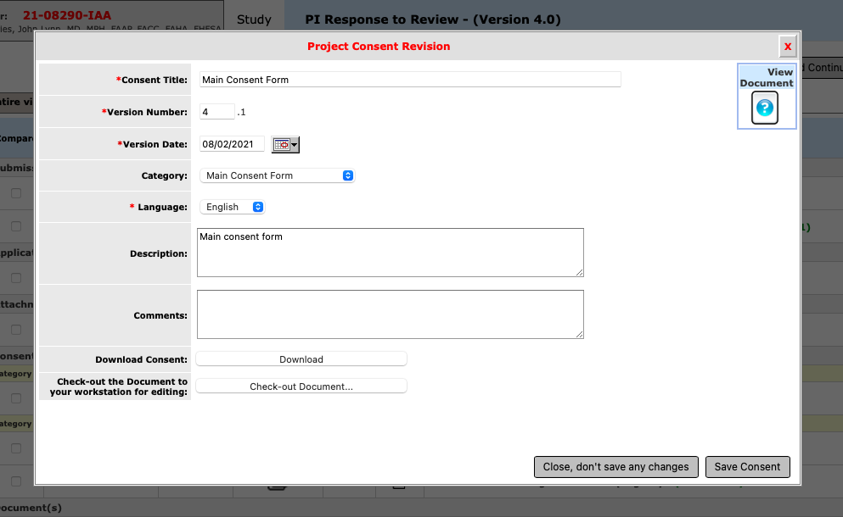
Once you click this button, WAIT. A pop-up will appear after a few seconds asking you to confirm if you want to check out the document. You want to save it to your computer, in a location (such as your desktop) and with a title that you will remember. If you are on a Mac the document will download for you.
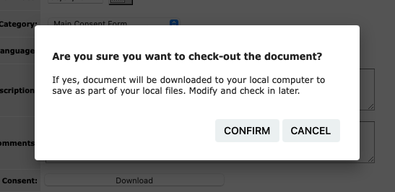

Next, open the Word document that you saved on your computer (e.g., on your desktop) and make any revisions requested by the IRB.
Note: DO NOT use tracked changes in Word. You can compare your old document with your newly revised document using the “Compare Documents” feature in iMedRIS later if you wish to check your revisions. In addition, the IRB cannot properly stamp a document that contains tracked changes. Lastly, if you already have tracked changes on your consent form, accept all changes and then turn tracked changes off (see http://www.uthsc.edu/research/research_compliance/IRB/docs/MicrosoftWordTrackChanges.pdf , a guide on our website for assistance with tracked changes).
Also Note: Any changes that you make that were not requested by the IRB must be delineated in question #3 of the PI Response form. Make notes of these changes as you go through your consent form so that you can list them when you get back to the PI Response form.
After making the changes to your consent form, be sure to save the Word document, and go back to your internet browser window. There should be a pop-up window on your screen that looks like this, showing in red text that the document is currently checked out by you:
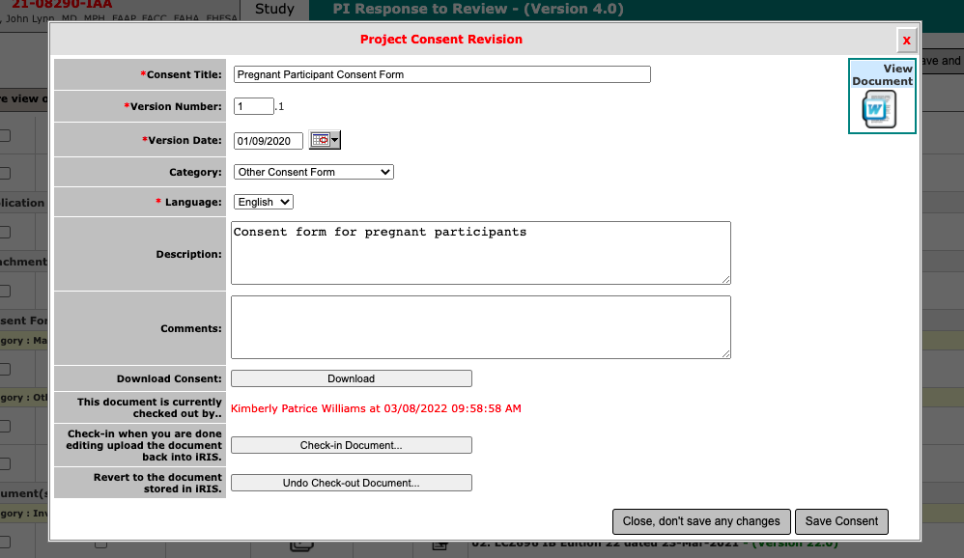
Click “Check-in Document.”
Another pop-up window will appear (see below) where you can browse your computer for the revised consent form that you saved. Click “Browse” (see the red arrow) and then “Save Selected File” (see the green arrow).
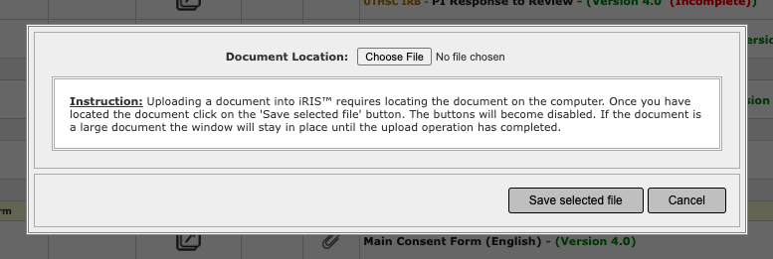
The last pop-up window will show the “Check-out Document” button in the event that you need to make any more changes to it.
Be sure to enter the Consent Title, such as “Main consent form”, “Control consent form”, or “Repository consent form”.
In addition, you should revise your Version Date label to match the revision date inside your consent form.
Further, be sure to select the correct appropriate Category, such as Main Consent Form, Repository Consent Form, etc., so that your consent form is housed in the correct subfolder within your “Consent Forms” folder in iMedRIS.
Additionally, the Version Number is created automatically by the system, so you do not have to change this.
Lastly, ensure the correct Language is selected, such as English (or Spanish or Other).
If all of your revisions are complete, click the “Save Consent” button.
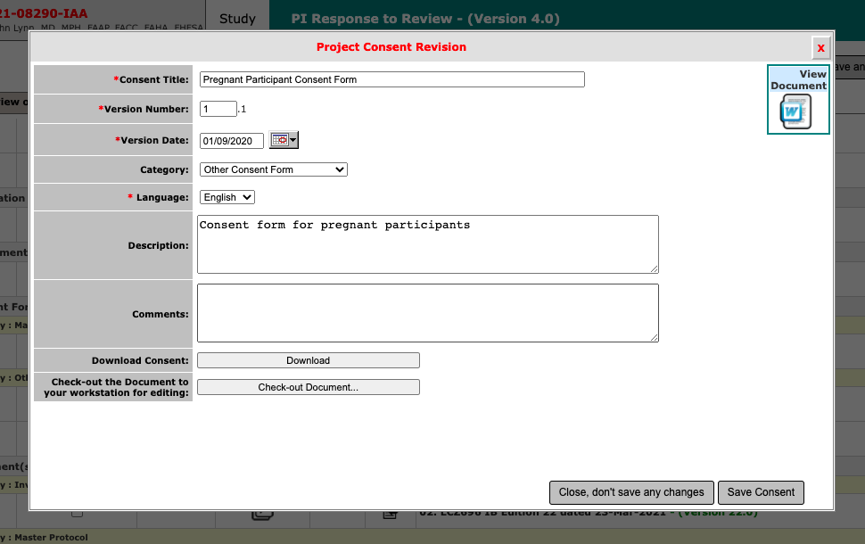
This will take you back to the PI Response Form and you will see the new version (1.1) of your consent form there (see the red arrow below).
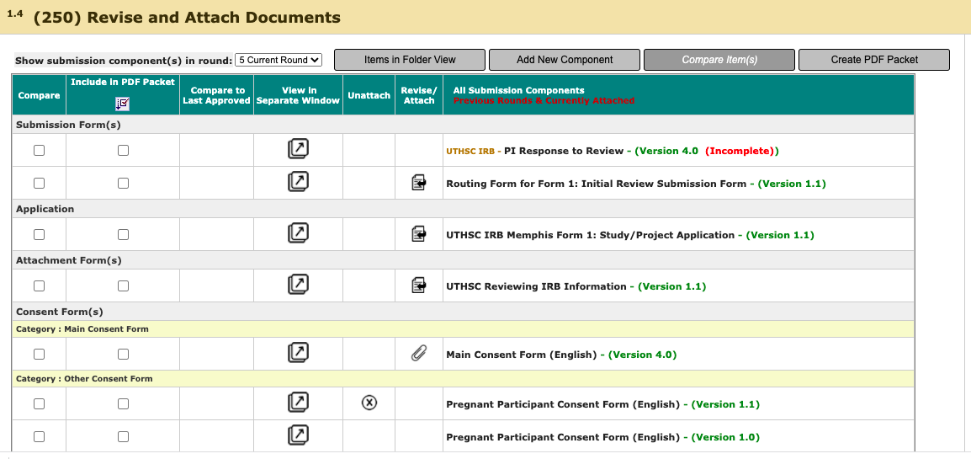
If you just wish to view the document that you checked back into iMedRIS, you can click on the name of the consent form (see the green arrow above). This will open up a new pop up window where you can click the Word icon on the right to view it (see the blue arrow below). Remember, however, that if you wish to make further changes, you have to check the consent form out, revise it on your computer, and check it back into iMedRIS as described on the previous page.
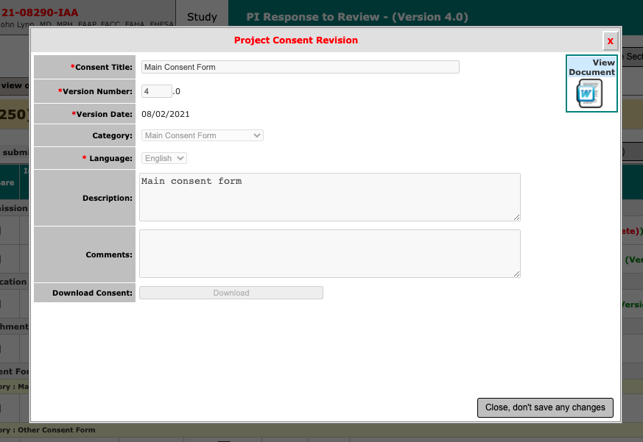

---------------------------------------------------------------------------------------------------------------------
If you have recommendations/provisos to ADD A NEW CONSENT FORM that you have never submitted to the IRB, click the button that says “Add New Component”.
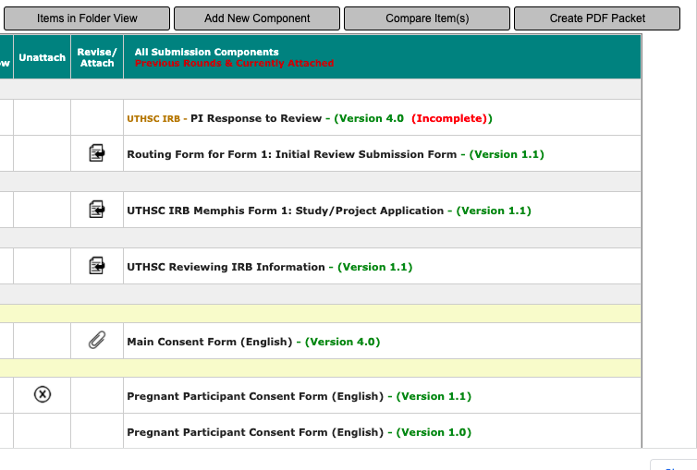

There will be a pop-up window asking what type of attachment you would like to add. You should click “Informed Consent.”

There will be a second pop-up window. You will see any consent forms that are already attached to your submission. To ADD A NEW CONSENT FORM that you have never submitted to the IRB, click on “Add Consent” (see red arrow below).
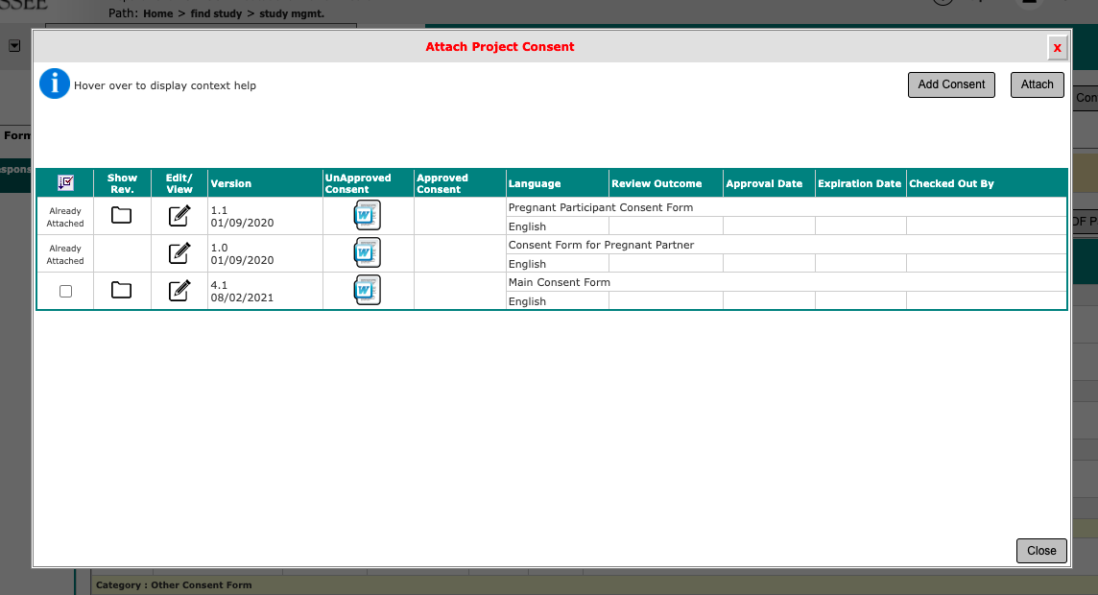
A pop-up window will appear. Please note: You will need to download the appropriate consent form templates at http://www.uthsc.edu/research/compliance/irb/researchers/consent-forms.php and create and save your consent form prior to filling out the PI Response form so that your session does not time out.
Click the option, “Upload a New Document Not on the List”,
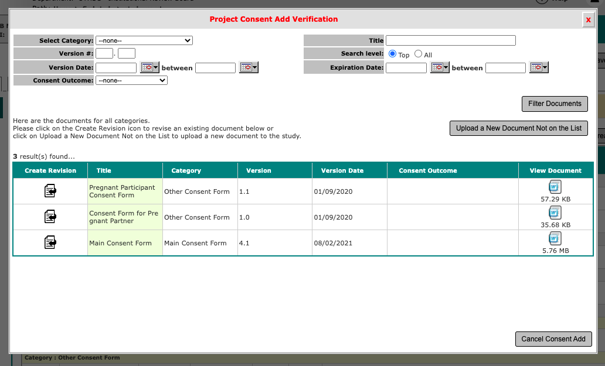
Another pop-up window will appear (see below). Double click the space or drop your file to the box titled “Select the consent to upload” (see the red arrow).
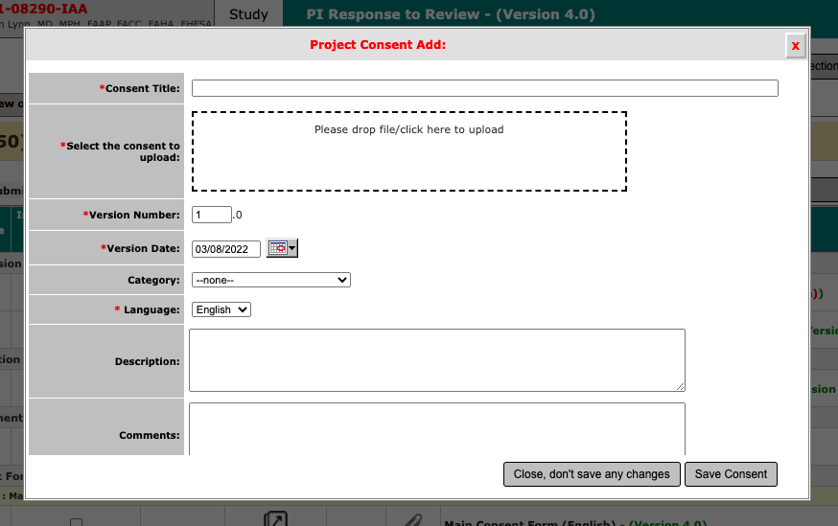
Fill out the fields to the left of the screen including:
- Consent Title such as Main Consent Form, Control Consent Form, Repository Consent Form, etc.
- Enter your Version Date to match the new date inside your consent form.
- Choose the correct Category, such as Main Consent Form, so that your consent form is housed in the correct subfolder within your “Consent Forms” folder in iMedRIS.
- Enter Version Number “1”.
- Ensure the Language is set to English (or Spanish or Other).
Click “Save Consent”

This will take you back to Section 250 of PI Response Form ” and you will see the new consent form that you uploaded there (see the red arrow below). To attach the newly created consent form to the submission, click the paperclip icon (see green arrow).
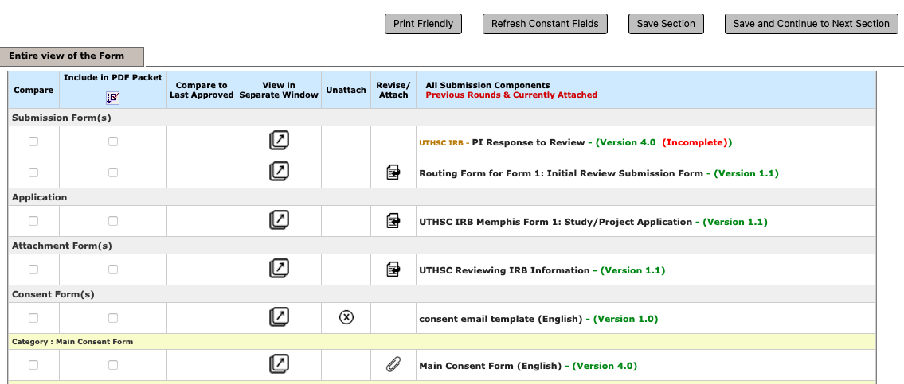

---------------------------------------------------------------------------------------------------------------------
If you have recommendations/provisos to REVISE another type of DOCUMENT, such as an investigator’s brochure or questionnaire, click the icon in the column entitled “revise/attach” next to the document you want to revise. You will go through the same check-out & check-in process as explained above when revising a consent form.

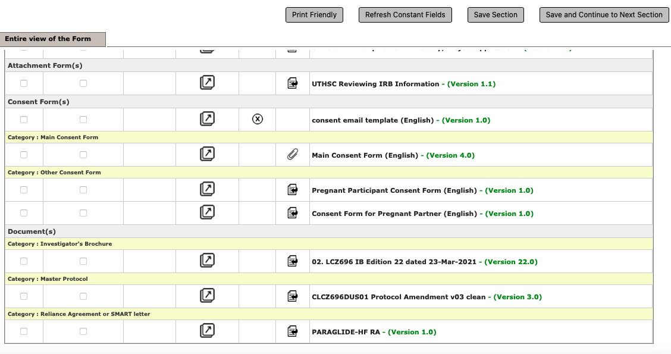

---------------------------------------------------------------------------------------------------------------------
If you have recommendations/provisos to ADD A NEW DOCUMENT that you have never submitted to the IRB, click the button that says “Add New Component”.

There will be a pop-up window asking what type of attachment you would like to add. You should click “Other Project Document.”

A new pop-up window will appear. Click “Add a New Document” in the top right corner.
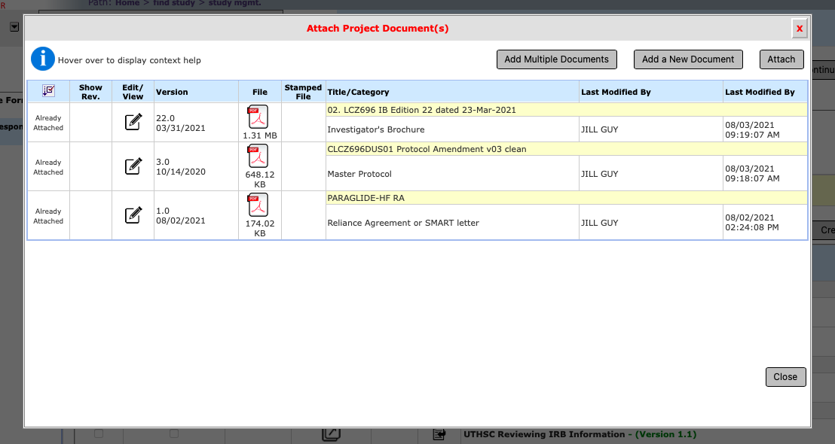
In the new window, click “Upload a New Document Not on the List” to upload your document (see red arrow below). Another pop-up window will appear (see below). Double click the space or drop your file to the box titled “Select the document to upload” (see the red arrow). Then, fill out fields provided including: Document Title, Version Number, Version date and Category (the latter is important for housing it in the appropriate subfolder within your Other Project Documents folder in iMedRIS). Finally, click “Save Document” (see green arrow below).
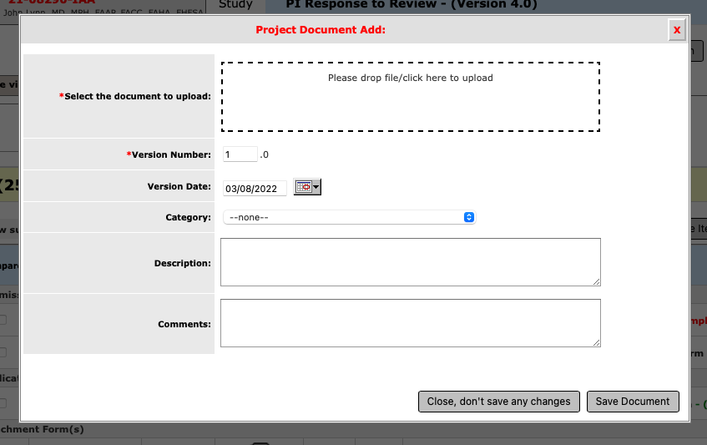
This will take you back to Section 250 of PI Response Form ” and you will see the new document form that you uploaded.

---------------------------------------------------------------------------------------------------------------------
Note: If your iMedRIS session has timed out and you have to log in again, open the corresponding incomplete task on your home page labeled “Submission Response” or “Submission Correction.” Then, scroll down to section (250) Revise and Attach Documents to continue your revisions.

To complete the PI Response form, answer all 3 questions in the text boxes provided below each question.
Question #1 pertains to recommendations (those instructions/questions sent to you before the submission goes to the Board meeting). Not everyone will get recommendations. If there are no recommendations listed, type “N/A.” If there are recommendations, list the ones that you did not answer and indicate why you did not answer them. In addition, if a recommendation does not require a change in the application, consent form, or any other document, you can simply address the issue in the text box.
Question #2 pertains to provisos (those instructions/questions sent in a letter from the Board). If there are no provisos listed, type “N/A.” If there are provisos, list the ones that you did not answer and indicate why you did not answer them. In addition, if a proviso does not require a change in the application, consent form, or any other document, you can simply address the issue in the text box.
Question #3 pertains to any changes that you made that were not requested by the IRB; these must be delineated in this text box.
Lastly, read the instructions in section (300) regarding routing for signatures. You may want to print those instructions. When you are certain of how to route the submission and to which key study personnel, click “Sign and Submit” (if you are the PI) or “Notify PI to Signoff” (if you are anyone other than the PI). You will now begin the routing process for signatures.
If you need any additional assistance, please contact the IRB office at (901) 448-4824. We can also schedule one-on-one training if necessary.

