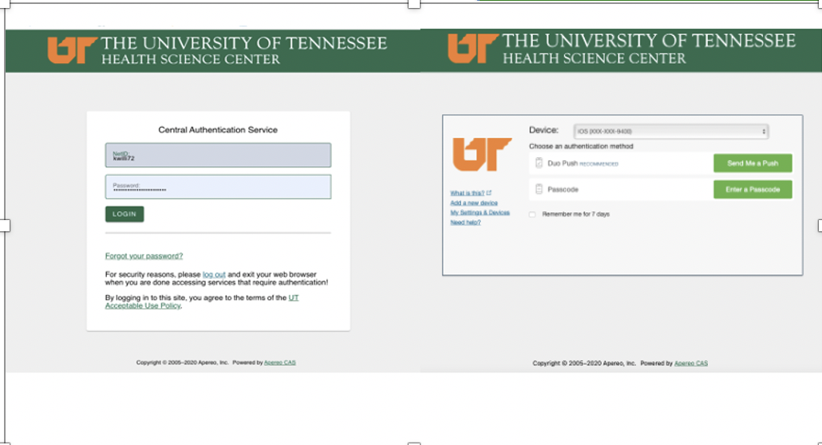
2022
Revised: March 15, 2022

Form 2: Change Request & Amendments

How to Submit a Form 2: Change Request/Amendment via iMedRIS

- Open your web Open your web browser. Make sure you are using a version of an Internet browser that is supported by iMedRIS.

- Chrome
- Edge
- Firefox
- Safari
- Type in the iMedRIS home page web address https://imedris.uthsc.edu (bookmark this page) and you will be directed to the DUO login screen. Please note, prior to accessing iMedRIS, you will need to install the “DUO Mobile App” https://www.uthsc.edu/its/cybersecurity/duo/. The University requires this two-factor authentication to protect against cyber-attacks.
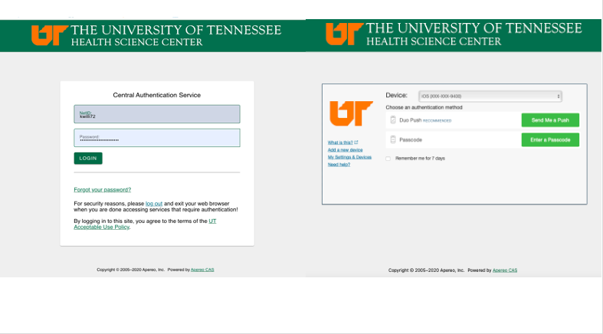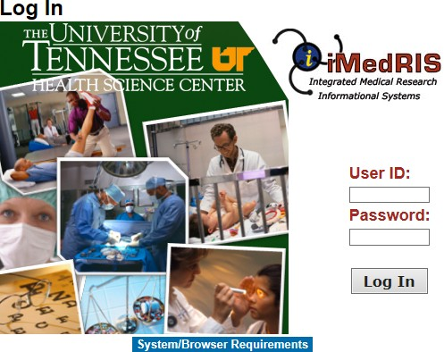

- The will take you to your iMedRIS homepage. On the top left side of your screen, under the My Workspaces tab, hover over/highlight Study then click on View and Manage My Studies. Note that if you are already in the Study tab, you can also click View and Manage My Studies under the Featured Project Operations section at the top of the page.

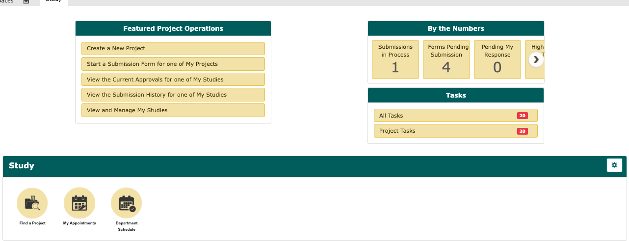

OR
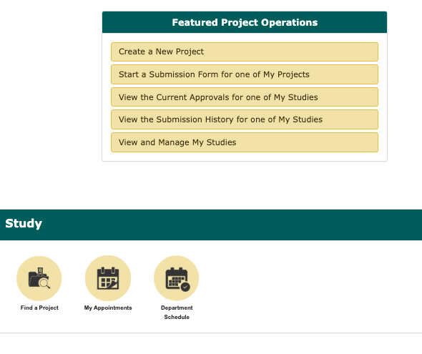
- Scroll to the bottom of the home screen and will see your list of studies/projects. Click to open the study you wish to change/revise.
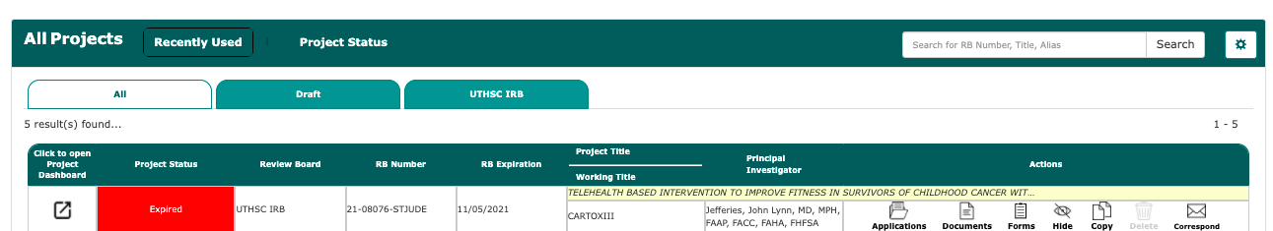

- On the Submissions screen, click Form 2: Change Request and Amendments.

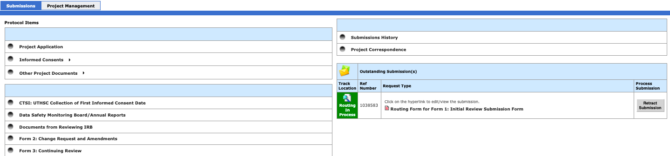

- Click Add a New Form to open a new Form 2: Change Request/Amendment.

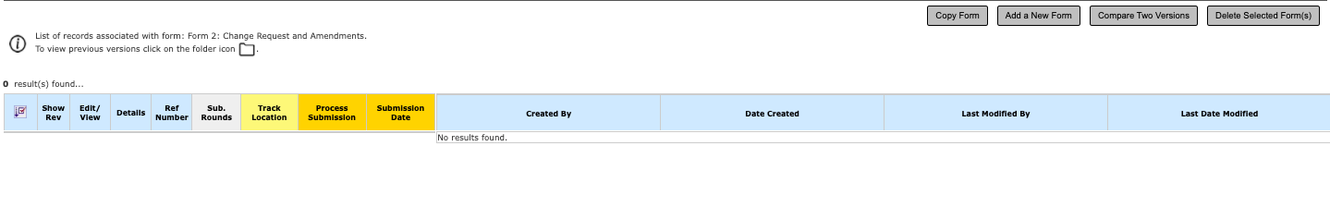
The first section of the Form 2 (Section 1.0, Question 1.1) provides general information about your study. In Section 1.2 of the Form 2, indicate the number of subjects that are approved for your study and currently enrolled in your project (if any). You must provide a response to each question. Once you have answered each question, click Save and Continue to Next Section

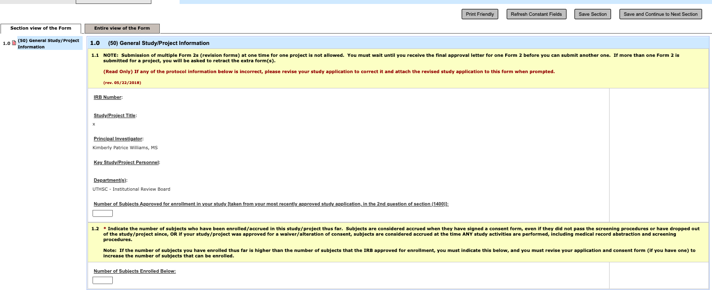
- If you forget to respond to a question, you will receive an error message. Click Ok and make the appropriate correction. Click Save and Continue when you are done.

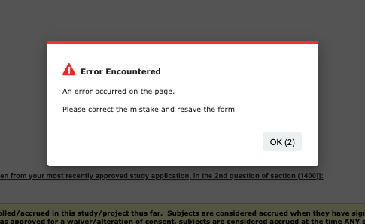

- In Section 2.0, Question 2.1, choose the status of the study from the list of options provided.
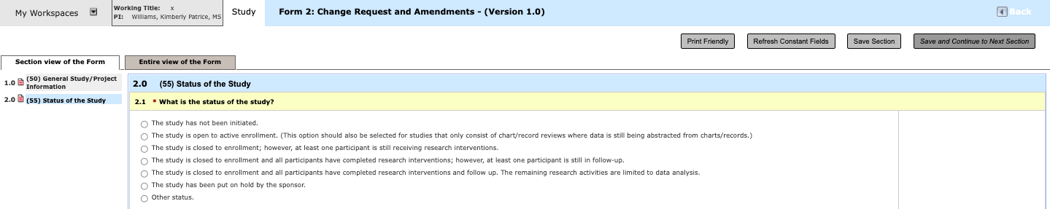

- In Section 3.0, choose which study documents are being revised.
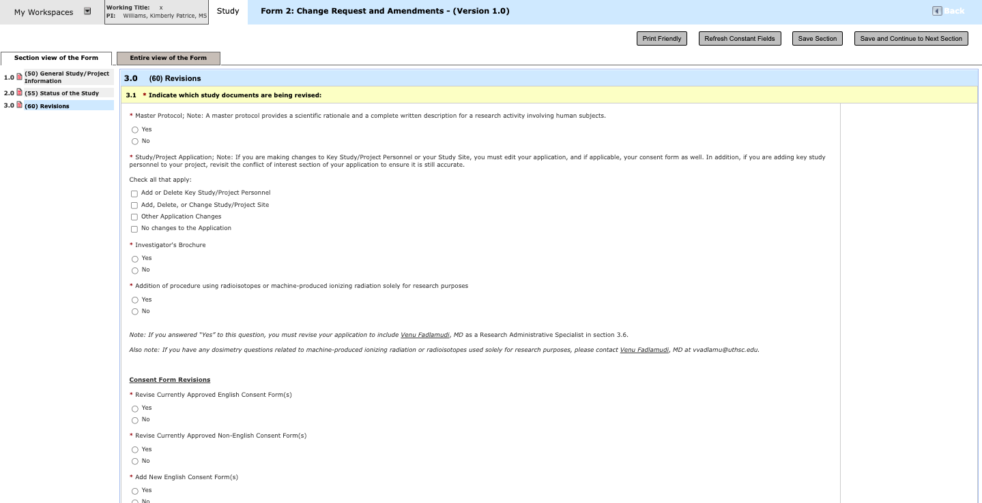

- On the next screen, select Click here to add another entry to describe the changes/revisions that will be made to the electronic study application, if applicable. You should add a new entry for each section of the application that is revised. Note that if you have not selected any changes to the application on the previous page, you will not receive this section of the Form 2.

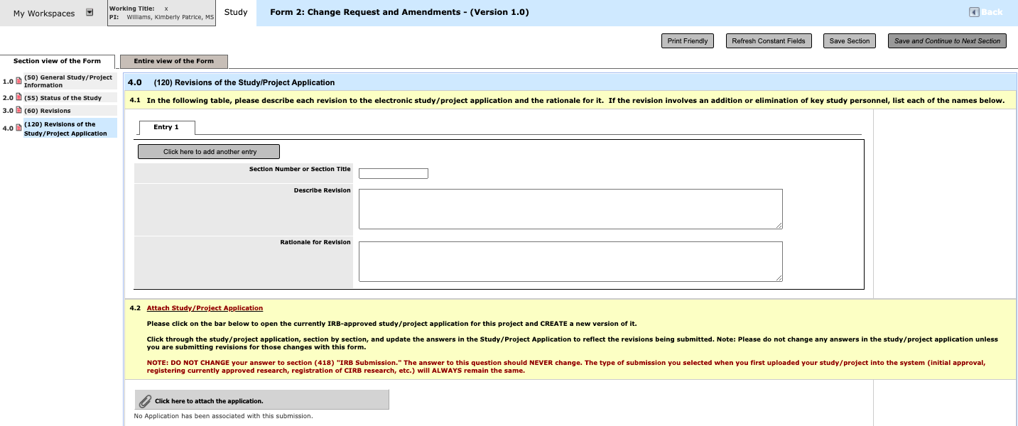

- Describe each revision and click the gray bar to revise and attach the new version of your study application.
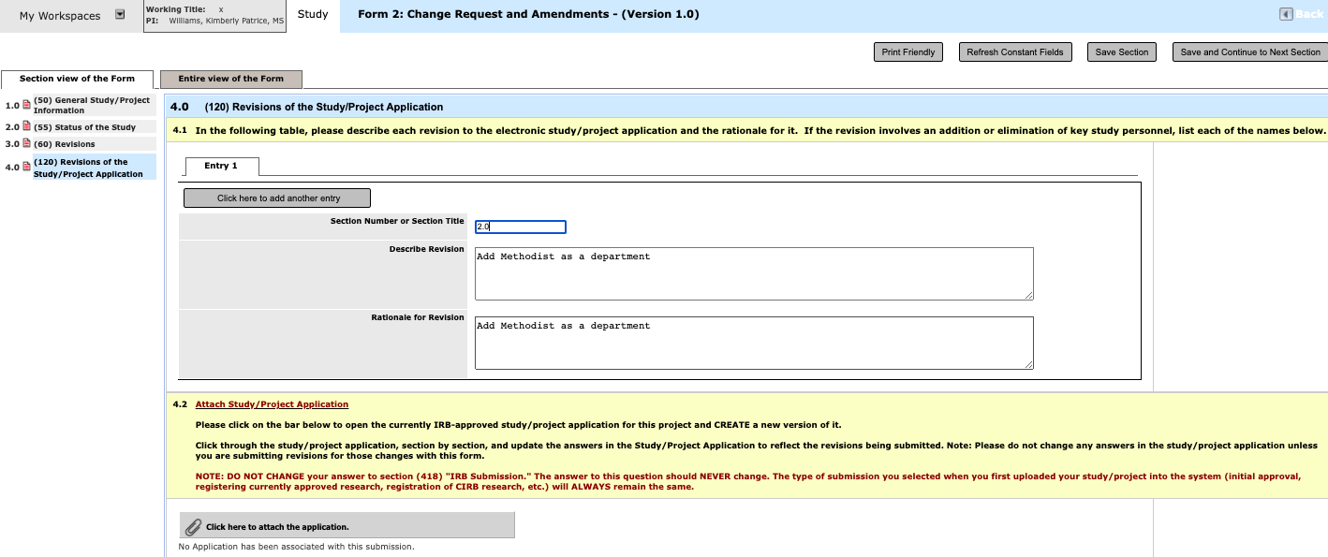

- You will see each version of your study application that has been reviewed and approved by the UTHSC IRB. Click Add Revision to incorporate your changes/revisions to study application.

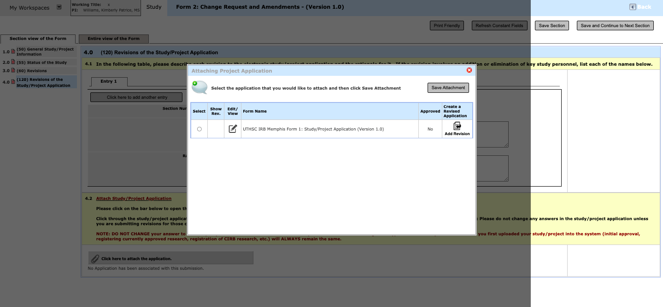

- You will be asked to confirm that you want to create a revision to your study application. Select Ok.

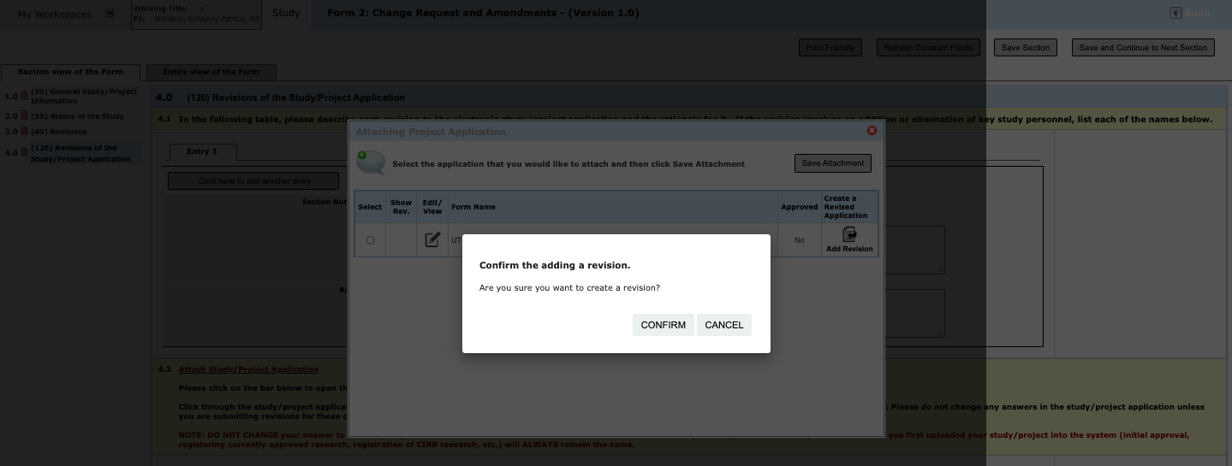

- If you receive the following message, click Convert to New Form Version.
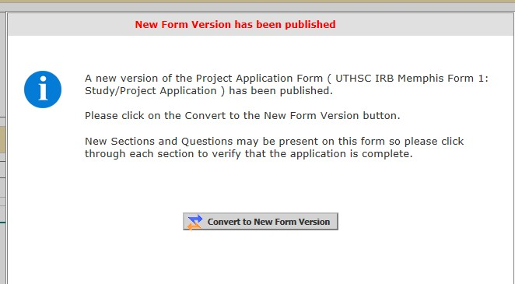

- A new version of the application will open for you to modify. Be sure to click Save and Continue to Next Section after each change is made.

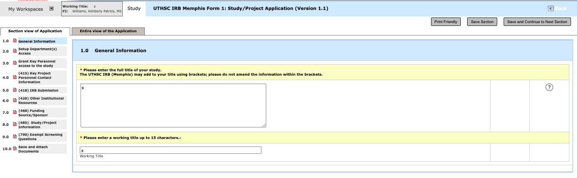

- When you have completed the revisions to the study application, the revised study application will be attached to your Form 2. If you need to make additional changes to the application, click Edit/View to open and revise the application.
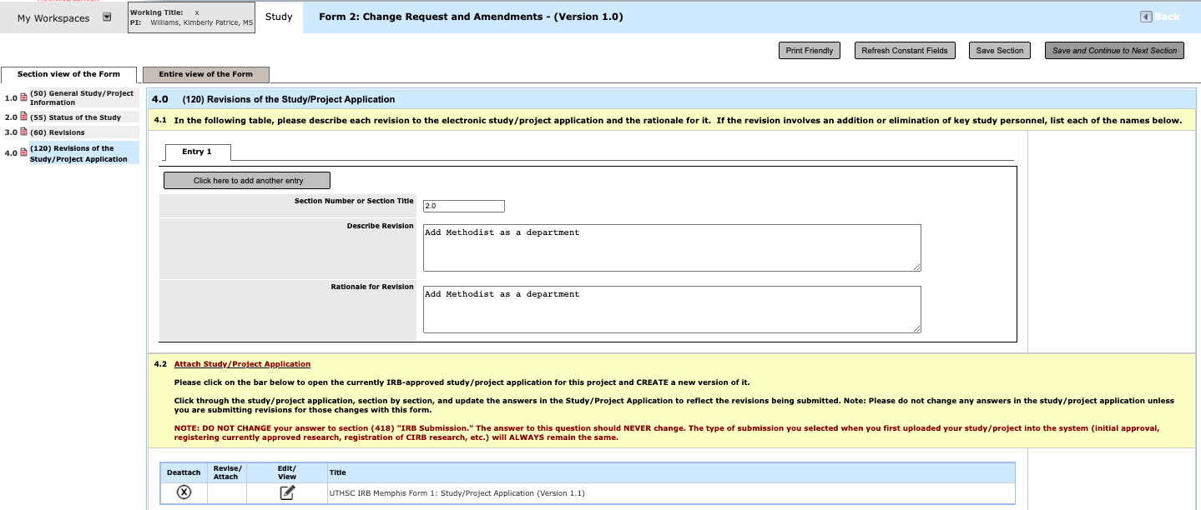

- Once the revisions to the study application are complete, Click Save and Continue to Next Section.
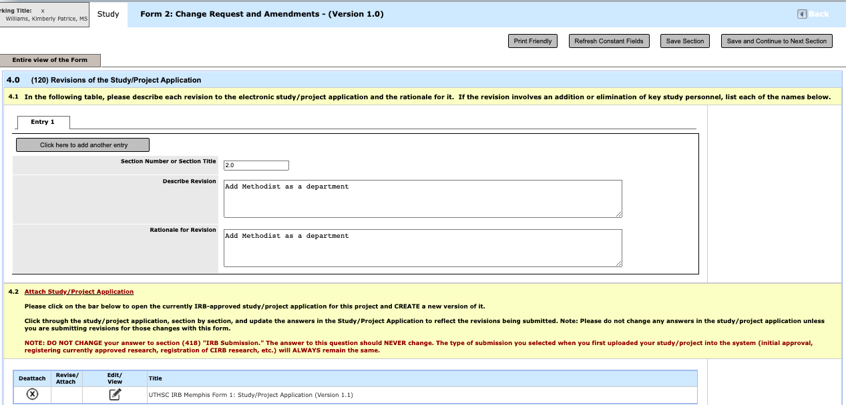
- If you need to make changes to your consent form, you will need to describe each of the changes/revisions, just as you did with the study application. Select Click here to add another entry to describe each change.

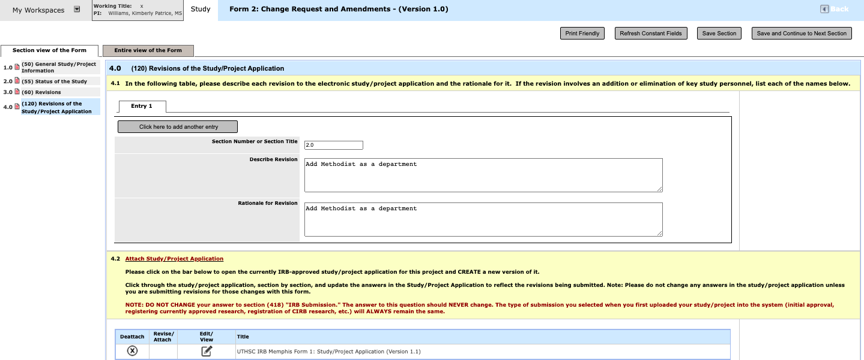

- To revise and attach your updated consent form, click Select or Revise Existing.

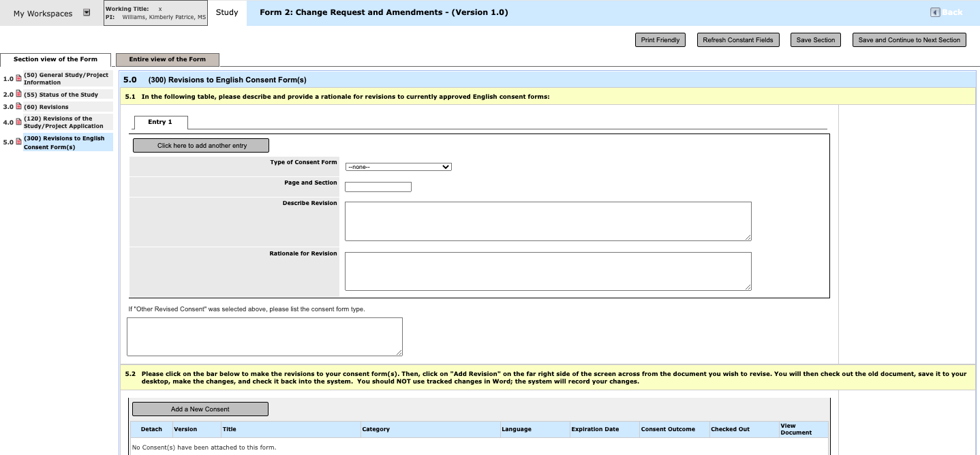

- Next, you will create a revised version of your currently approved consent form so that you can make the appropriate changes. Click the icon under Create Revision.

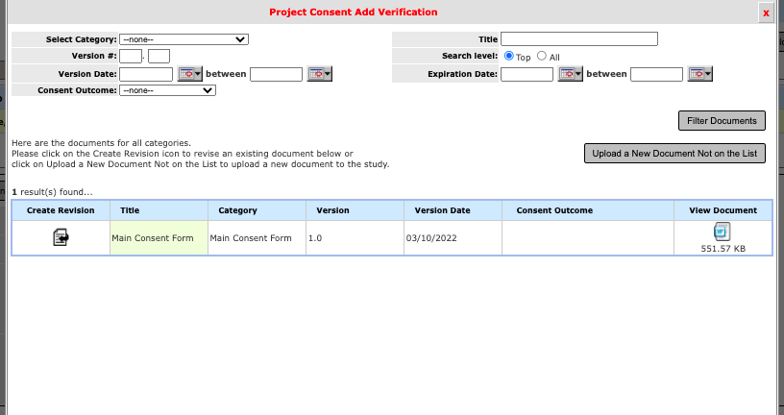

- Next, you will want to check out the consent form to make appropriate changes. Select Checkout-out Document.

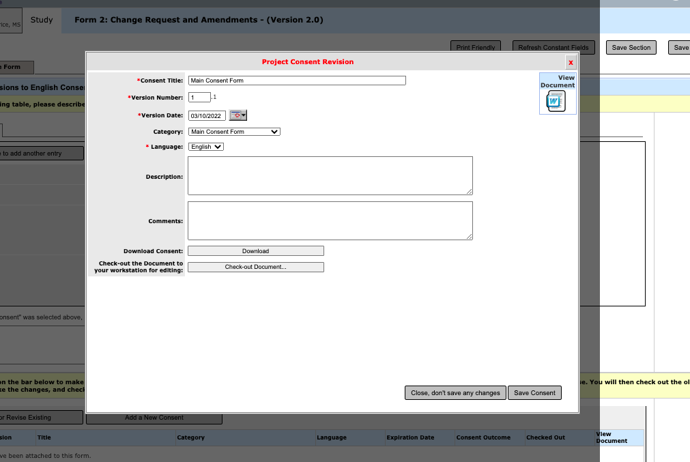

- The window will pop up to ask if you are sure you want to check out the document. Click Confirm.
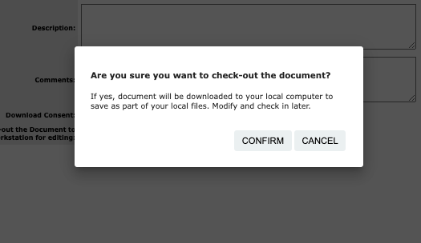

- Your consent form will open in Word (or will be downloaded if you are using a Mac) so that you can make the appropriate changes. Once you have completed your changes to the consent form and updated the preparation date in the footer, save a copy to your computer.

- Next, you will receive a prompt asking if you would like to check the document back into iMedRIS. Click Check-in Document.

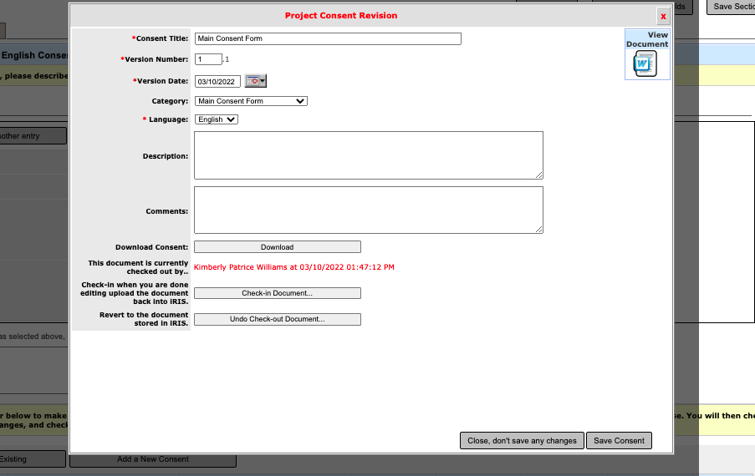
Locate the revised consent form on your computer by clicking Choose File. .

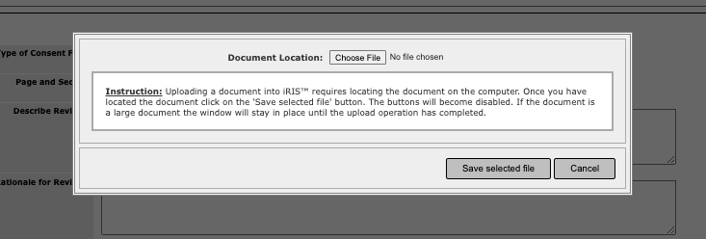

- Locate the document on your computer, select it, and click Open.

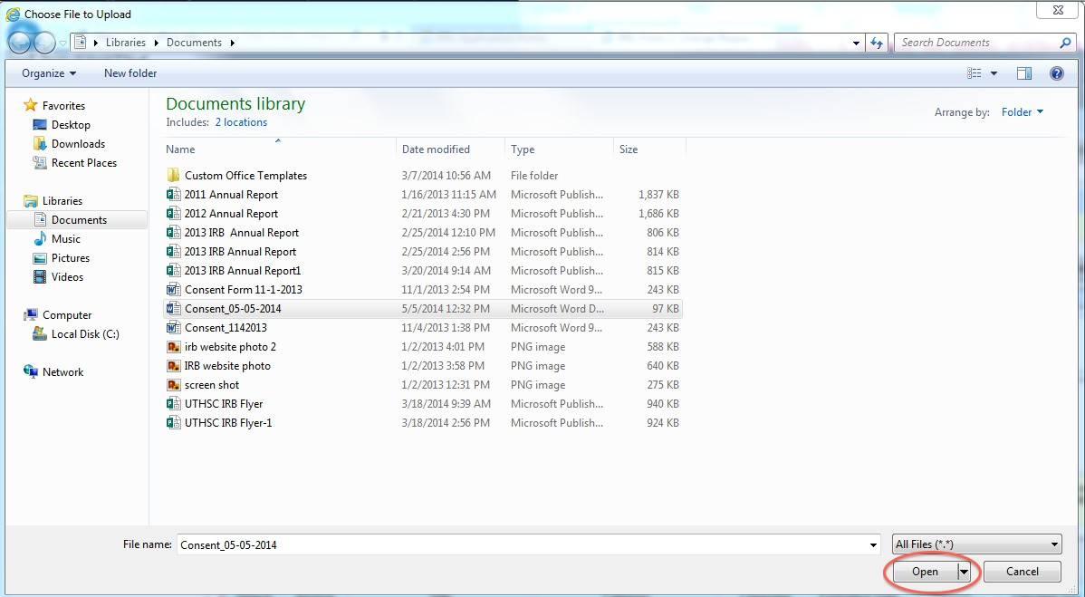

- Next, select Save selected file and the document will be uploaded into iMedRIS.

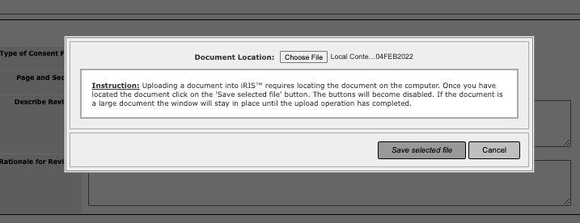

- Make sure that the consent title, version number, and version date are correct and click

Save Consent.

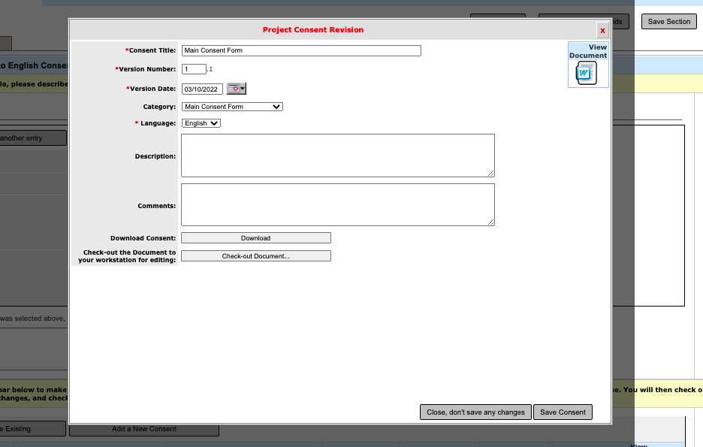

- The revised version of the consent form is now attached to the Form 2.
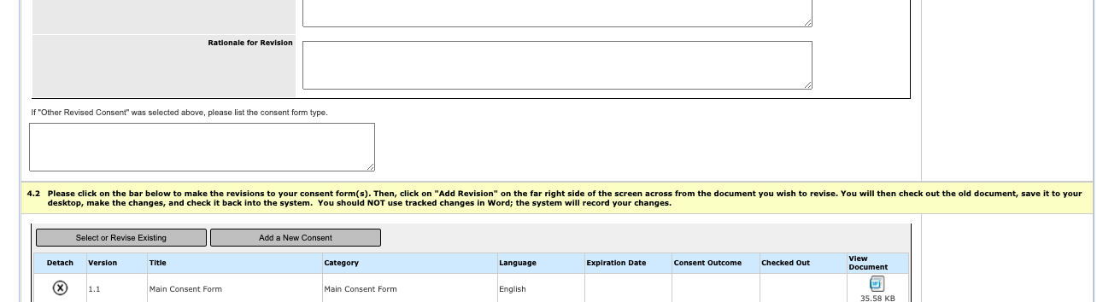

- Once you have outlined each of the change(s) to the consent form and attached the revised consent form, click Save and Continue to Next Section to move to the next screen.

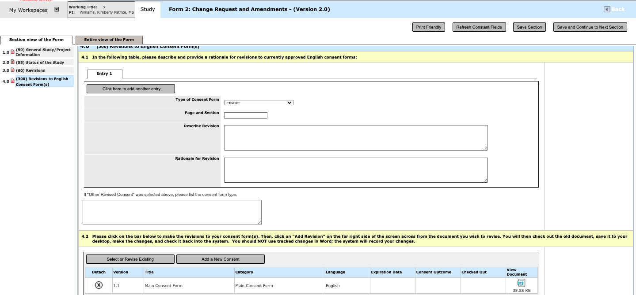

- Address whether the changes affect the risk/benefit ratio and click Save and Continue to Next Section.
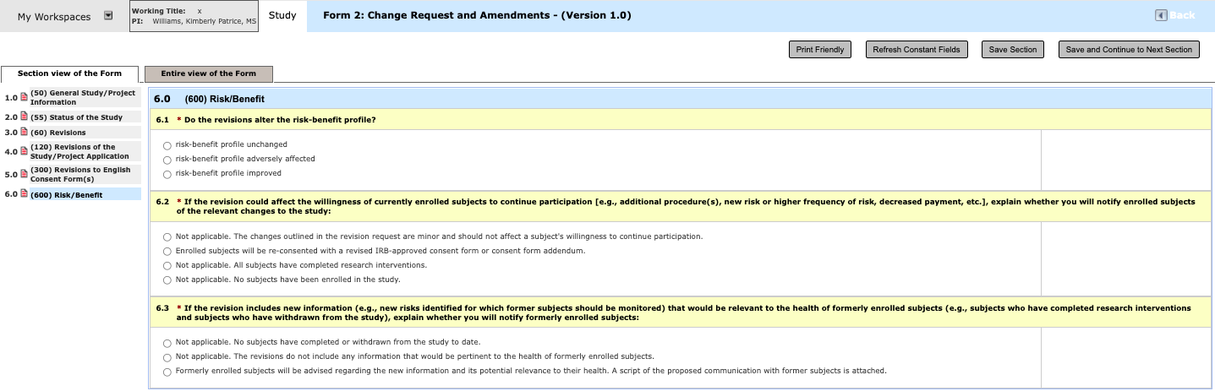

- Next, indicate whether you have any additional study documents to attach. If you do, click the appropriate gray button and follow the same steps for attaching study documents as outlined above. If you have no additional study documents to attach, indicate this and click Save and Continue to Next Section.

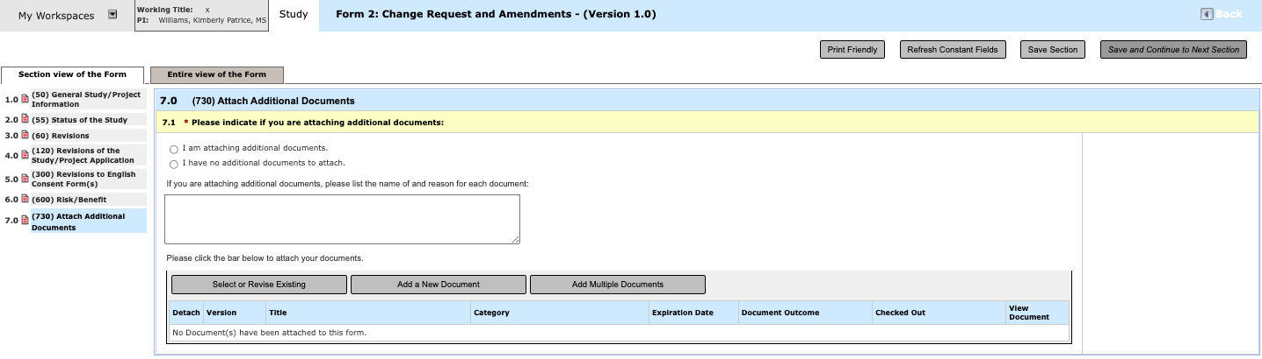

- Next, click Sign and Submit to route the Form for appropriate signature(s).

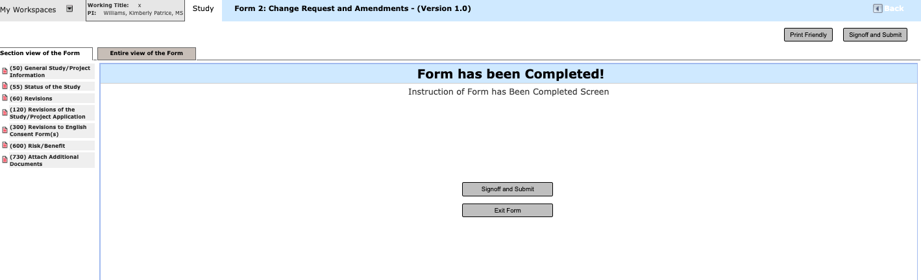

- To verify who will receive the Form 2 for signatures, click Save Selection and Continue the Signoff Process.

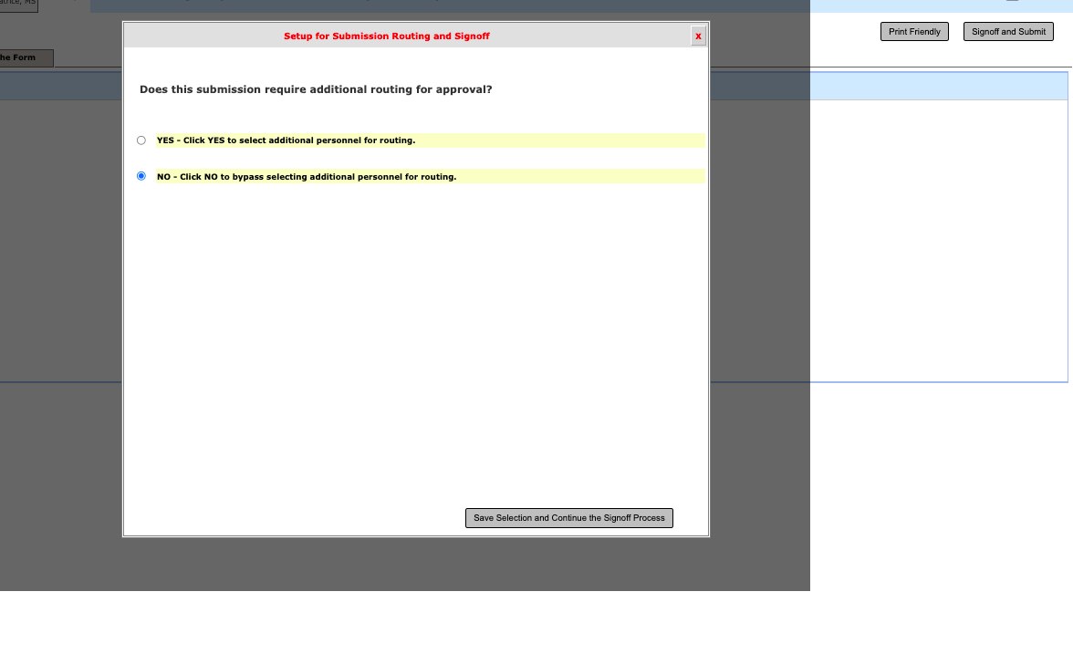

- Select the appropriate key study personnel for signatures. Note: If a new investigator(s) is being added to the study, the application will need to be routed to each new investigator for signature(s).

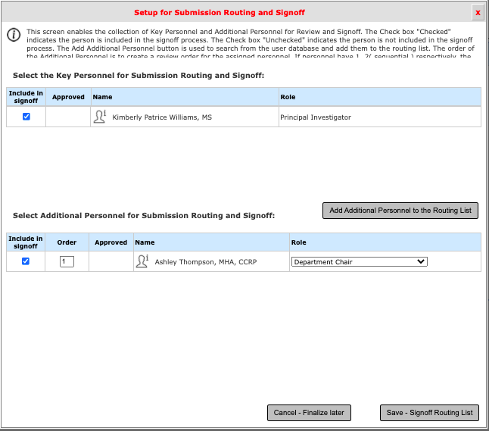
- Once you click Save-Signoff Routing List, you will be asked to verify that the list above represents the finalize Personnel for review and sign-off. If the list is correct, click Yes and then click Save-Start Signoff Routing. If not, click No and select Cancel-Finalize Later or Go Back to Make Changes.

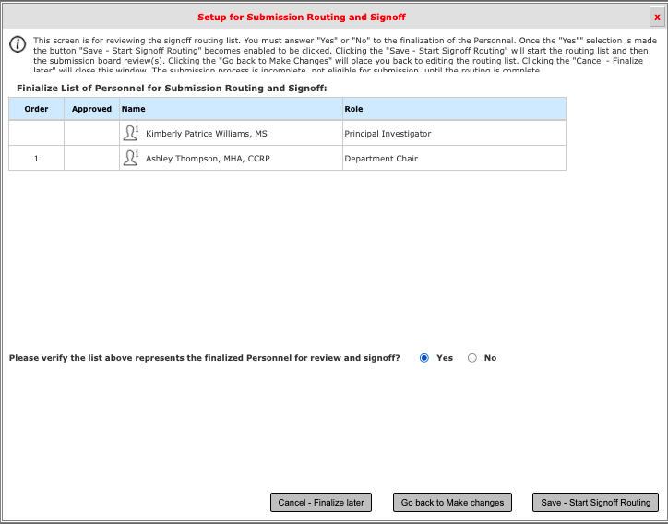

- You will then see the screen below. You may click OK or wait until the 10-second countdown ends, which will then take you to the PI Responsibilities screen

- You will then see the screen below. You may click OK or wait until the 10-second countdown ends, which will then take you to the PI Responsibilities screen

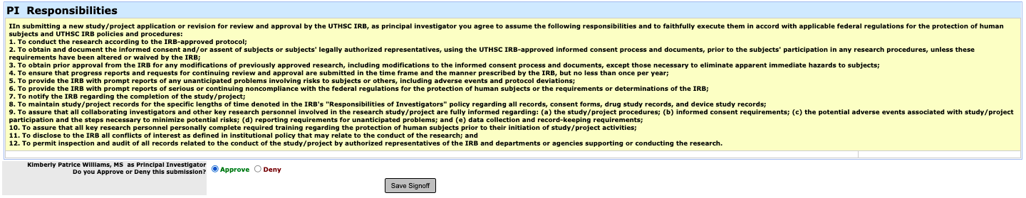

- You may verify the electronic signatures in the Workflow Tracking of iMedRIS.

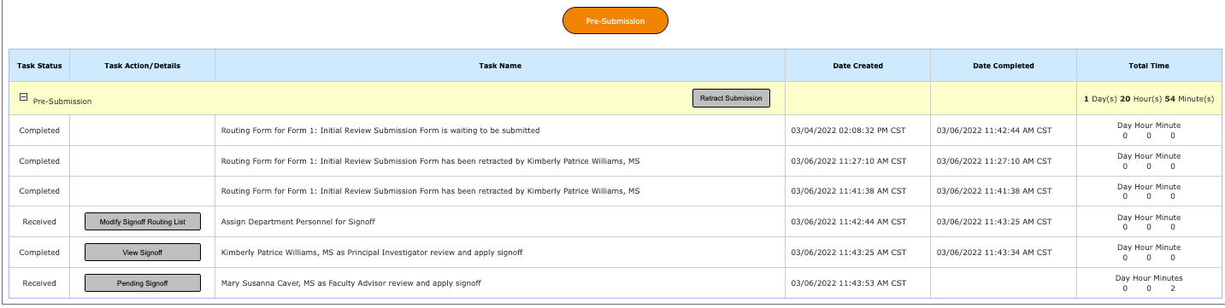

- For more instructions regarding routing and signoff, download the iMedRIS Guide Routing, Workflow Tracking & Signoff from the IRB website at http://www.uthsc.edu/research/research_compliance/IRB/guides.php. In addition, do not hesitate to contact the IRB office at 901.448.4824 for assistance.

