Burnout Survey 2016

Surveys emailed to Erlanger and UT physicians and residents = 685 Response received = 228
Survey response rate = 33.2% Faculty/Attending = 157
Residents = 71

Some characteristics of responders
Mean (SD) Age = 42.7 (12.9) years
Median Age (IQR) = 39 (21) years

Males = 149 (65.3%)
Females = 78 (34.2%) [one person didn’t answer question]

US Medical Graduates = 189 (82.9%)
Foreign Medical Graduates = 34 (14.9) [5 didn’t answer the question]

Specialty
Internal Medicine = 36
Family Medicine = 23
Surgery = 22
Emergency Medicine = 20 Pediatrics = 39
Others = 39

Satisfied with Job
Dissatisfied = 18
Neutral = 24
Satisfied = 119 Very Dissatisfied = 6 Very Satisfied = 59
Didn’t answer = 2

Recommend Erlanger or UT for employment to friends and family
Yes = 130
No = 18
May be = 78 Didn’t answer = 2

Do you sometime think about leaving Erlanger or UT?
Yes = 124
No = 100
Didn’t answer = 4

Burnout Evaluation: We used Oldenburg burnout inventory which has two dimensions of burnout and both need to be evaluated separately.

Overall Disengagement score on Burnout scale
Mean (SD) = -2.7 (3.4)
Median (IQR) = -3.0 (4)

Overall Exhaustion score on Burnout scale
Mean (SD) = -0.36 (3.8)
Median (IQR) = 0.0 (5)

Disengagement Exhaustion

Gender
Males | -2.9 | -0.76
Females | -2.4 | 0.39

P-value 0.35 0.03

 | Specialty
Cardiology | -1.5 | -0.33
EM | -1.9 | -0.42
FM | -1.7 | 0.14
IM | -3.5 | -1.09
OBGYN | -1.9 | -1.12
Ortho | -2.8 | 0.71
Others | -2.7 | 0.13
PEDS | -2.9 | 0.10
Plastics | -2 | -2.5
Surgery | -4.1 | -1.32
Urology | -2.2 | 1.33
P-value 0.38 0.54

Attending/Resident
Faculty/Attending | -3.15 | -0.77
Resident | -1.77 | 0.54
P-value | 0.005 | 0.008

Figure: Overall distribution of the two burnout dimension (upper) and distribution by gender (middle) and attending/resident status (lower)
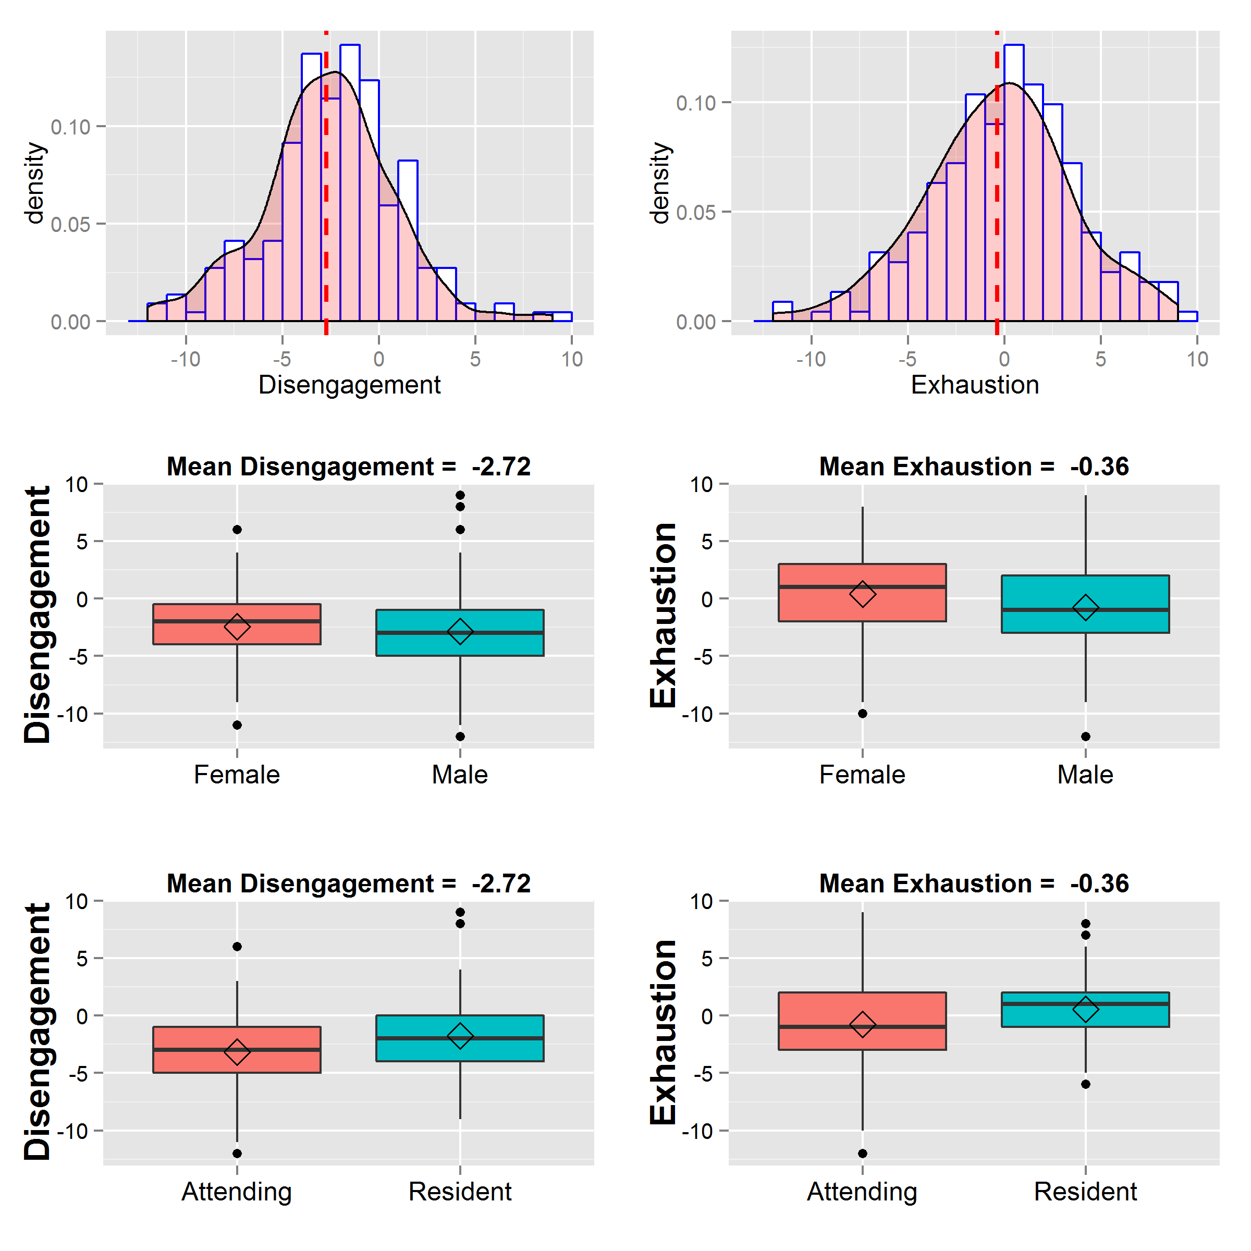

Figure: Comparison of different specialties by burnout dimensions
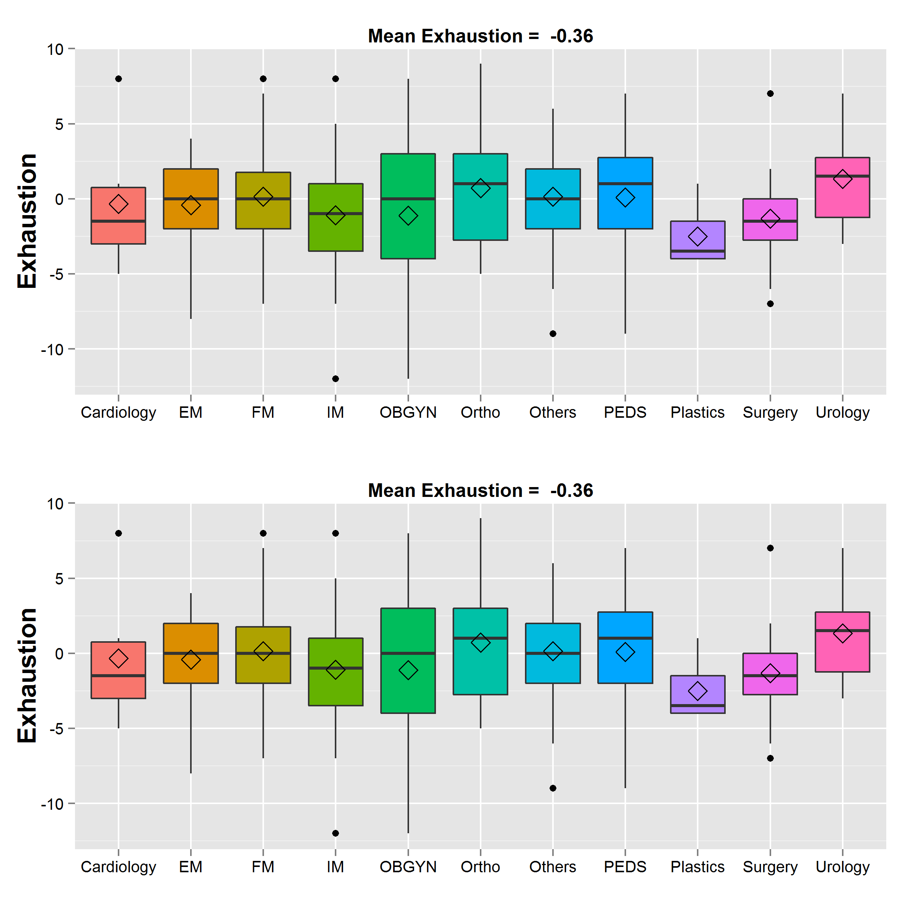

Rehan Qayyum, MD, MHS, FAHA

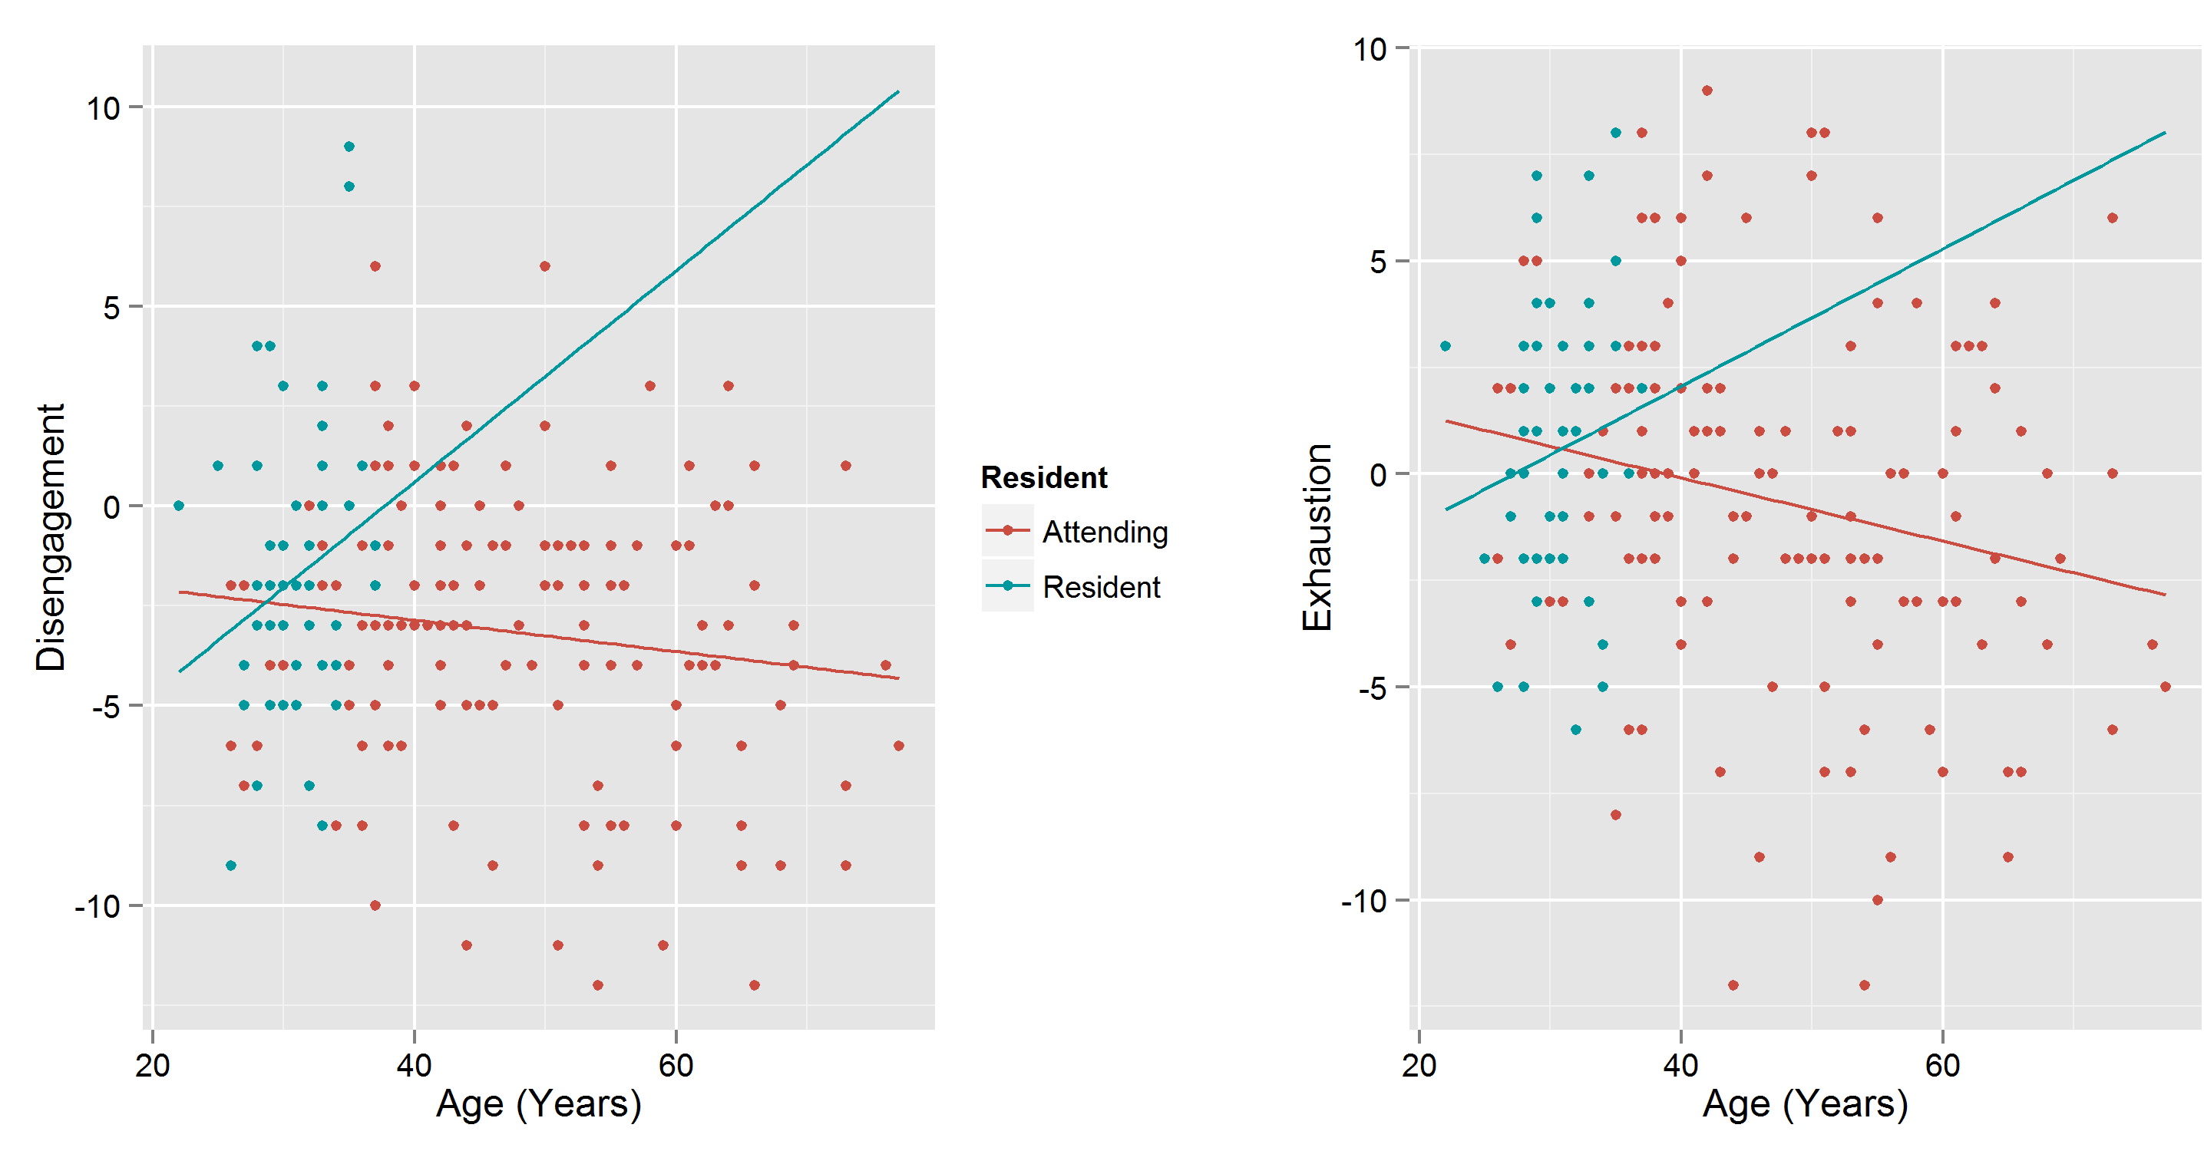
Figure: Modifying effect of age on burnout dimensions by attending/resident status

5 | P a g e

