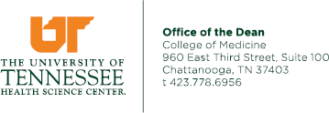
UT Chat GME DIO Digest
November 2023, Volume 4

From Your DIO: Deans/GME Staff

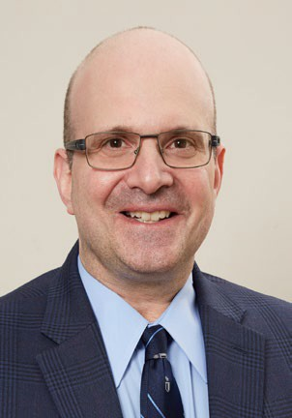




Announcements:
James W. Haynes, MD, MBA Professor, Dean

Paul M. Schwartzberg, DO, MBA Associate Dean, Academic Affairs
Designated Institutional Official (DIO)

Michael S. Greer, MD, FACS Interim Assistant Dean, Undergraduate Medical Education

Crystal Maddox, MPA Assistant Dean for Finance & Administration

Giuseppe Pizzorno, PhD, PharmD
Professor, Associate Dean for Research

Pamela D. Scott, C-TAGME Director, Graduate and Undergraduate Medical Education

Rosalyn Stewart-Kalaukoa, BS, AS
GME Lead Residency Coordinator

Lucy White, MEd, LPC/MHSP GME Counselor

Tiffany Nabors, CMA (AAMA) Medical Student Services Specialist
- Medical Library Holiday Open House, Thursday,Dec.
7,9am-1pm, UTCOM-C Medical Library Whitehall Building,3rd floor. Stop by to speak with our Medical Librarians about research services/databases on our campus. Grab a research "goody bag" and refreshments while you’re there!

Pam Scott will be taking some extended time off effective Monday, November 27th.
  - For questions/concerns about medical students, please contact Tiffany Nabors, Medical Student Specialist, 423.778.7442, tiffany.nabors@erlanger.org
  - For questions/concerns regarding GME, please contact Paul Schwartzberg, DO, MBA, Associate Dean/DIO, 423.778.6956, paul.schwartzberg@erlanger.org or Rosalyn Stewart-Kalaukoa, GME Lead Residency Coordinator, 423.778.3894
rosalyn.stewart-kalaukoa@erlanger.org

Happy Holidays to all!!!
There will be no GMEC meeting or DIO Digest in December.



House Staff Gala, Saturday, December 16, 2023

On behalf of the UTHSC COM Chattanooga House Staff Association officers, we look forward to another magical holiday event celebrating our physicians’ contributions to medicine.
Please join us for this black-tie affair. Each ticket purchased will include a seated dinner, two drink tickets, and unlimited dancing with a live band.

Cost:
$75 resident ticket, $150 attending ticket
House staff are each allowed to purchase one guest ticket of the respective monetary designation ($75 resident guest, $150 attending guest).

Additional levels of sponsorship are available:
Silver Sponsorship: $600 (two tickets; program recognition) Gold Sponsorship: $1200 (four tickets; program and podium recognition)
Platinum Sponsorship: $1800 (six tickets, program and podium recognition)
Diamond Sponsorship: $2500 (ten tickets, program and podium recognition, reserved table for group)
Departmental Sponsorships will also be recognized for departments who cover the costs of their residents' attendance. Departments can purchase a bulk amount of resident tickets.
Residents should discuss this with their department before individually purchasing a ticket.

Tickets and sponsorships may be purchased via check and should be submitted by December 12th. You will RSVP for the event by clicking the "Register Now" link on this website: https://www.eventcreate.com/e/utc-com-hsg

The last day to register is December 4th, 2023. We kindly ask that you use the reservation space to nominate an outstanding faculty member within your program as well as a resident who you feel is excellent in all aspects of practice. You will need to provide your name, name of guest, meal preferences, and vote for faculty/resident awards. We also ask that you bring a children's book to support our House Staff Association's efforts to provide these to the Children's Hospital.

Each guest will be allotted two drink tickets. A full-service cash bar will also be available. Valet services will be available at $10 plus tip, however, we encourage utilizing a ride share to this event. If there are any questions, please do not hesitate to contact the UT House Staff President, Hayley Everett, at hayley.everett@erlanger.org

Happy Holidays!
Hayley Everett, MD, President Chace Hicks, MD, Vice President Skyler Smith, DO, Secretary Justin Bailey, MD, Treasurer
Arpita Yadav, MD, Hospital Liasion

GMEC Subcommittee Updates

CLER Save the Dates
Annual House Staff Gala and Awards Dinner Saturday, December 16, Westin Hotel
See page 2 of this digest for more details

2024 Alper Humanitarian Awards/Keynote Speaker
May 3, 2024
7:30-9.30 am
Probasco Auditorium Speaker: James Kahn, MD, Emeritus Professor, Department of Medicine, Stanford University
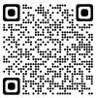

The Clinical Learning Environment Review (CLER) program augments residency and fellowship training programs by bridging with organizational goals in areas of quality and safety, emphasizing team-building and professionalism, and ensuring well-being and appropriate supervision.

We expect a CLER site visit sometime soon. Want to learn more about CLER and what to expect? Follow this QR Code for ACGME.org to the CLER 2.0 Pathways guide:

PROGRAM EXPANSION
Excited to launch for 2024-2025:
- Neurology
- Primary Care Sports Medicine
- Pulmonary Critical Care (awaiting ACGME approval)

GME News and Announcements

Quality Improvement Patient Safety (QIPS) Day: Monday, March 11, 2024

Submission Deadline:

Notification of Platform/Poster Presentation: Monday, February 26, 2024
Acceptance will be either “Platform Presentation” or “Poster”

Finalized Posters/Power Points Due: Friday, March 1, 2024
submitted for QIPS Day!
PLEASE: Submit any project you have! It doesn't need to have been completed to be
Friday, February 16, 2024!!

All appropriate submissions at QIPS Day will be showcased.
Platform (juried) will be limited to the best 8 submissions received, based on use of QI methods and impact factors. The top presentation will be honored on QIPS Day!!
See more details and platform/poster presentation specifications at:
https://uthsc.edu/comc/quality/qips-day.php

We look forward to receiving your QI Project Submission!!

For more information, please contact:
Jeffrey Bennett, MD, MBOE, Director of Quality for CLER jeffrey.bennett@erlanger.org or QIPS@erlanger.org
or
Adam Campbell, PhD, VP Quality and Patient Safety, Erlanger Health Systems adam.campbell@erlanger.org

November Faculty Participation
UTC Ethics in Medicine Event
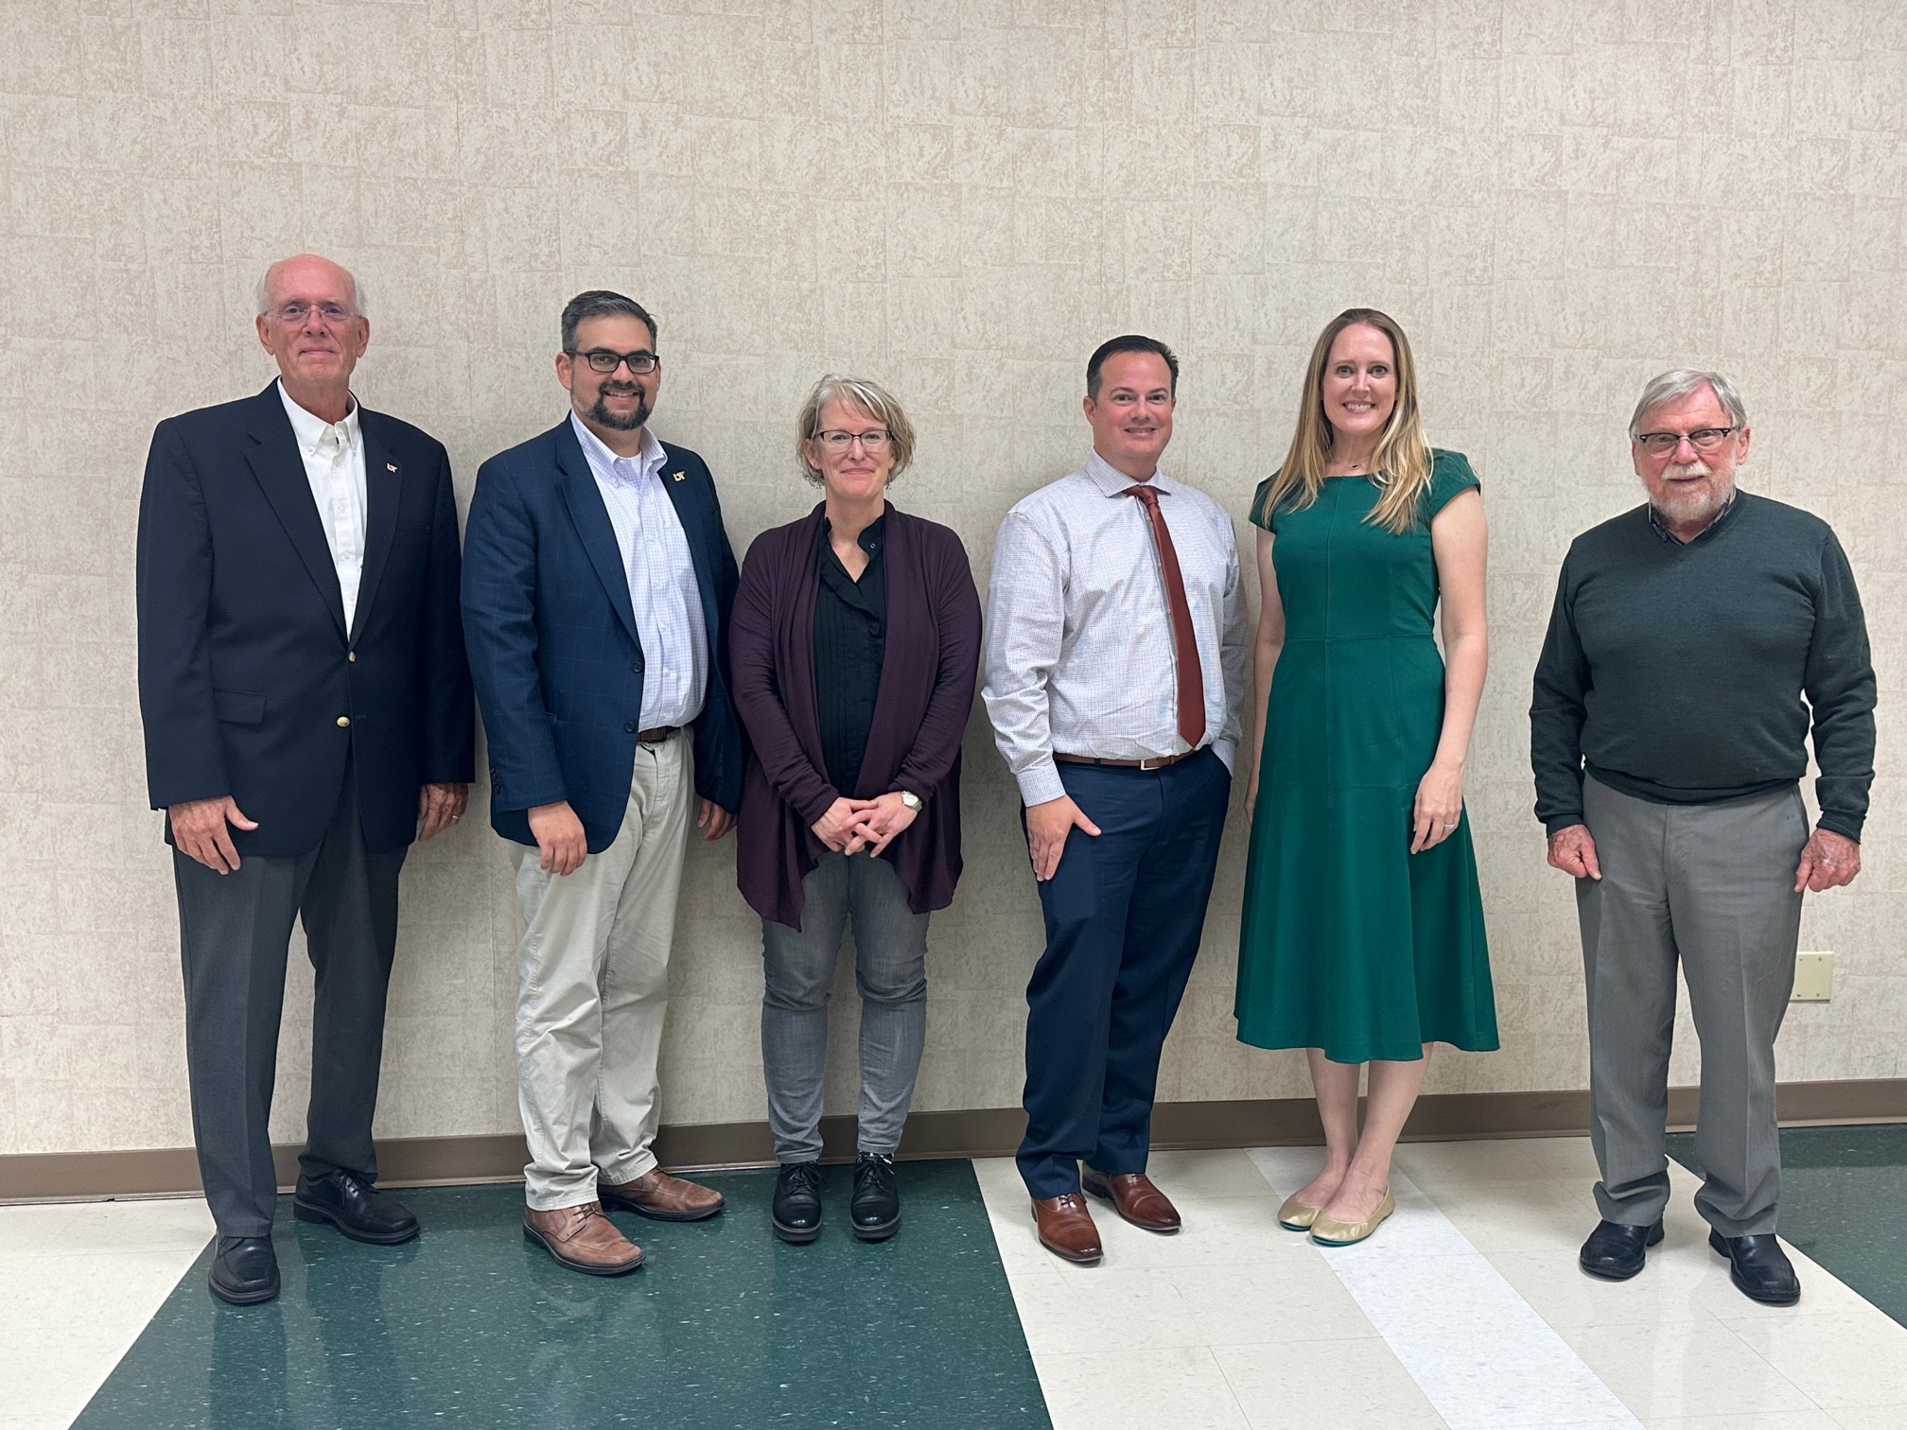
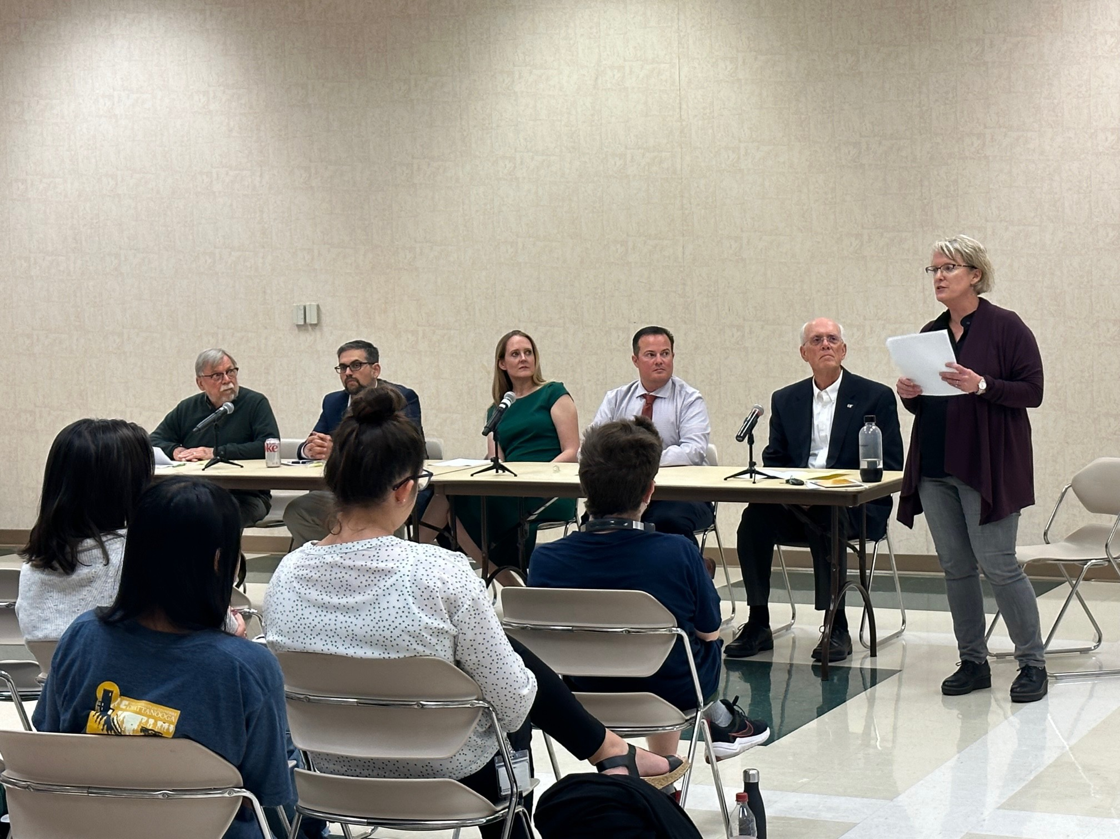

UTHSC COM-C at Legislative Dinner

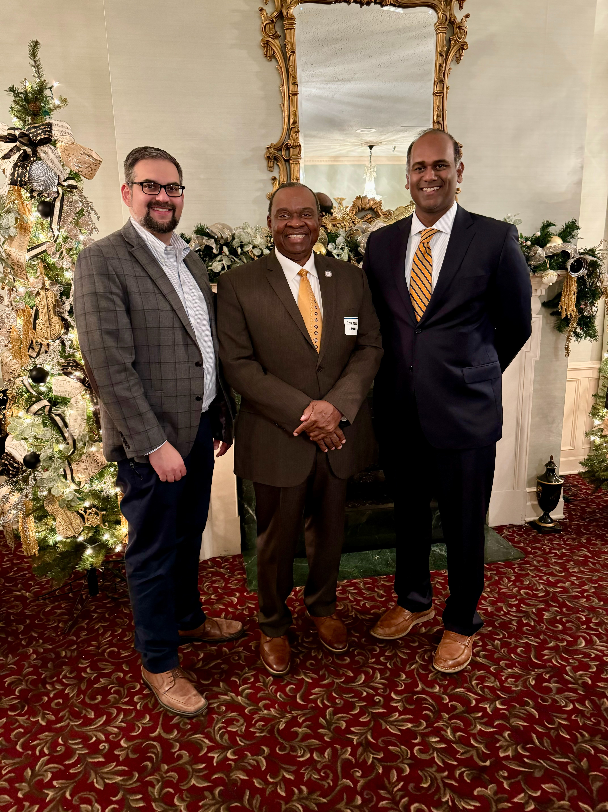

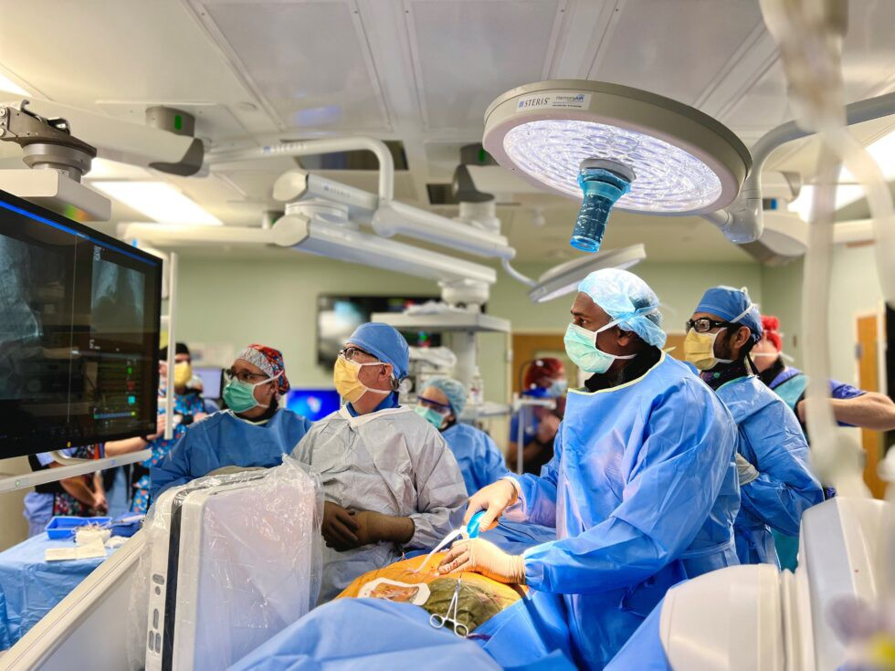
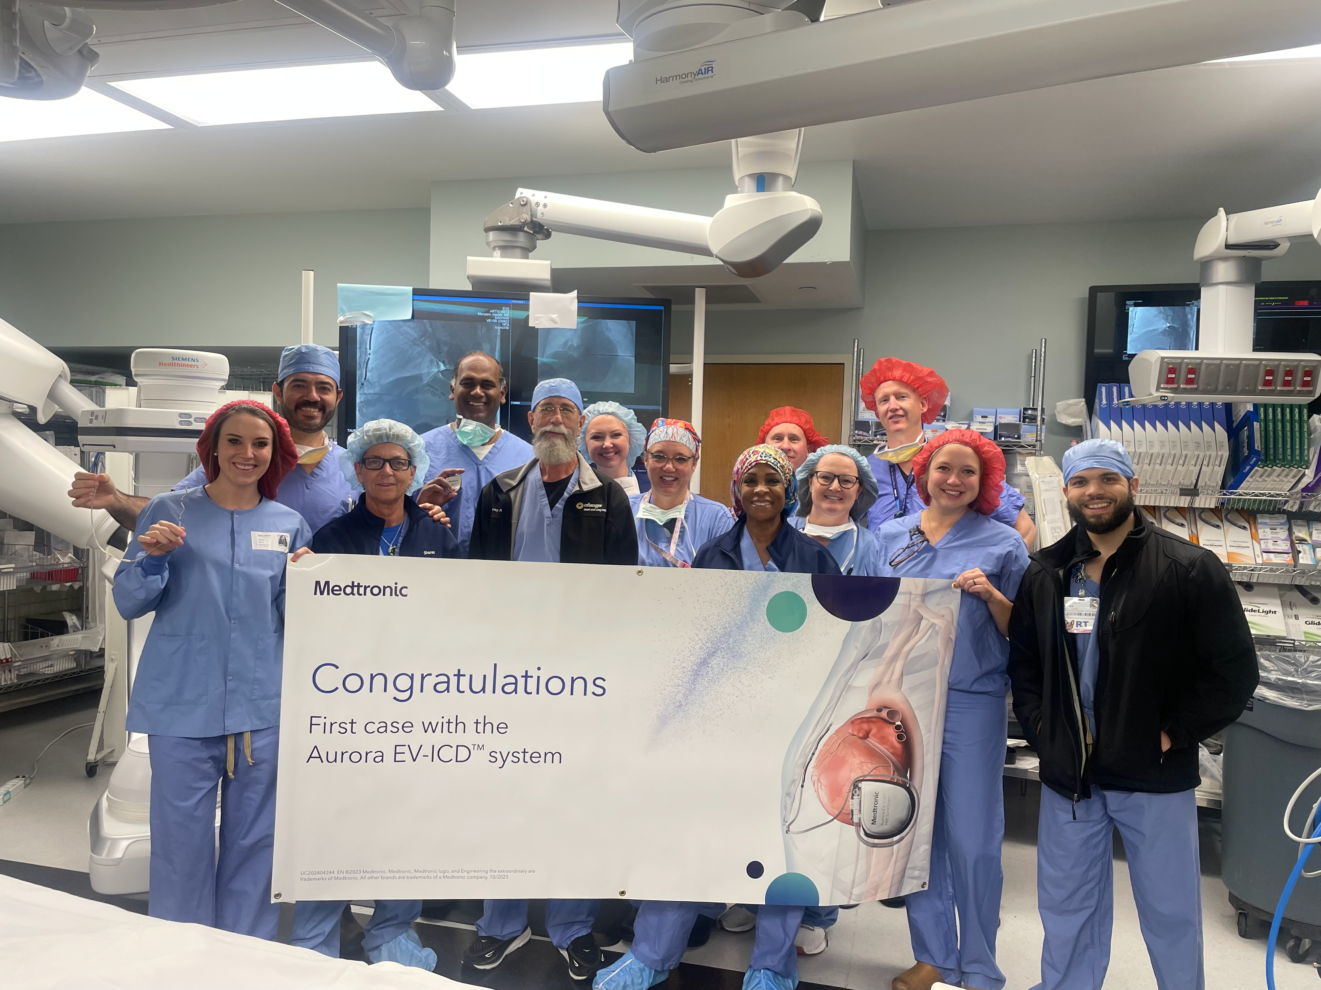
Erlanger Cardiology Team

Congrats Dr. Harish Manyam and the Erlanger Cardiology team!
On Tuesday, November 14th, Dr. Manyam and the Heart and Lung Institute was the first in the country to implant an Extravascular Implantable Cardioverter Defibrillator (EV-ICD) under the sternum. This defibrillator allows patients to not have anything touching the heart and reduces long term complications.
(https://blog.erlanger.org/2023/11/17/a-groundbreaking-milestone-in-heart-care-erlanger- cardiology-team-leads-the-way-with-extravascular-icd-implantation/? fbclid=IwAR0bNRaGayOSkwRjYV1YTGHBm_bWisQmQ7lrmPXzUDLNq1NPrJxueJppC6o_ae m_Aar3N0g1MeSogqHLH0Yr_--Bhv3JGHI4rG51-z2g_gIZIBQ1nxWT8IiGTpFmgtGX-dQ)

COORDINATORS CORNER
We want to thank all our Residency and Fellowship Program Coordinators for their hard work and dedication!!! Coordinators are key to the success of each of our GME Programs.

Shout out!!!!!!! Congratulations to Kimberly Davis on her C-TAGME Certification.
Program Coordinators, ACGME-Accredited Programs

Cardiovascular Disease and Gastroenterology Fellowships:
Samantha Bond

Emergency Medicine Residency & EMS Fellowships: Velvet Green

Family Medicine Residency:
Elissa McCoy, MEd

Internal Medicine Residency:
Deborah Fuller

Neurology Residency:
J. Hayden Morris, BS

OB/GYN Residency:
Janie Boals, BA

Orthopaedic Surgery Residency:
Kimberly Davis, MEd

Pediatrics Residency:
Ashley Thurston, BS, C-TAGME

Plastic Surgery Residency:
Allison Ellis, AS Primary Care Sports Medicine: Elizabeth Eaves, MS,ATC, LAT
Surgery Residency and Subspecialty Fellowships:
Maggie Hamblen, C-TAGME, CAP
Cindy Rudolph, MS

Urology Residency:
Stacey Blanks, C-TAGME, CAP



CONGRATULATIONS!

Dr. Mukta Panda, Department of Internal Medicine
- Congrats Dr. Panda on being the 2023-2024 recipient of the American College of Physicians (ACP) Award for Outstanding Contributions to Improving Well-being and Professional Fulfillment in Internal Medicine!
Her award will be acknowledged during the 2024 Convocation Ceremony in Boston,
Massachusetts
https://www.acponline.org/about-acp/awards-masterships-and-competitions/acp-award- for-outstanding-contributions-to-improving-well-being-and-professional-fulfillment-in

Dr. Steven Fox, Department of Family Medicine
- Congrats Dr. Fox on presenting at the American College of Lifestyle Medicine!

New Programs:
- Primary Care Sports Medicine
Congrats Dr. William Hunter Garrett and Elizabeth Eaves for receiving Initial Accreditation from the ACGME/Family Medicine Residency Review Committee for their Primary Care Sports Medicine fellowship! The first fellow is scheduled to start July 1, 2024.

- Rural Track Designation/Family Medicine
Congrats Dr. Steven Fox, Dr. Leslie Griffin and Elissa McCoy for the Family Medicine residency program achieving a Rural Track Program (RTP) designation from the ACGME! Thank you for all your hard work and efforts to expand GME into our rural community.

Program Matches:
Congrats to the program directors/coordinators for matching fellows in the fellowship programs below -
- Colon and Rectal Surgery (CRS)
Taylor Wilkinson, MD, University of Oklahoma College of Medicine at Oklahoma City
- Clinical Ultrasound
Gabriel Autry, MD, Wake Forest University School of Medicine
- Emergency Medical Services (EMS)
Dax Spencer, DO, Lincoln Memorial University DeBusk College of Osteopathic Medicine

